SYSTEMS & SCALE

HIGH SCHOOL

TEACHER GUIDE

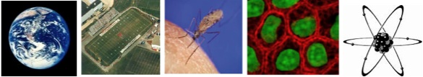

Environmental Literacy Project

Lindsey Mohan & Hui Jin
With help from Jonathon Schramm, Li Zhan, Andy Anderson, Valencia Moses, & Jim Ratcliffe,

Revised February 2009

Outlines of Activities:

Outlines of Activities: 2
Overview and Background for Teachers: 3
Embedded Assessments 7
Tools for Matter, Energy, and Scale 8
Scale 8
Powers of Ten Representation #1 8
Powers of Ten Representation #2 8
Matter and Energy 9
Molecular Model Kits 9
Matter and Energy Process Tool 10
Combustion 12
Flame Representation #1 12
Flame Representation #2 12
Activity 1: Powers of 10 14
Activity 2: Powers of 10 As A Tool 20
Activity 3: Using Powers of Ten 23
Activity 4: What is Air? 27
Activity 5: Energy and Machines 36
Activity 6: What Happens When Fuels Burn? 46
Activity 7: Does Burning Release Energy: Modeling Combustion 56
Activity 8: Identifying Energy-Rich Materials 70

Overview and Background for Teachers:

Our work on the Environmental Science Literacy Project has been to document the accounts students have for events that occur in natural and human social systems. At the macroscopic scale we documented students’ accounts of growth, weight loss, decay and burning and at the large scale we looked at their accounts of global warming and deforestation. The goal of our work has been to develop a learning progression that describes how accounts of changes in matter and energy develop from grades 4-12. One important conclusion from this work, and our experiences in classrooms, is the following: When students enter school they use narratives (or stories) to explain how the world works. This is the students’ natural discourse. The information they learn in science class teaches them more detailed narratives and new vocabulary, and students try to fit the new information into their existing narratives. Thus, students tell the same stories with more details, instead of learning new, more principled accounts about their world.

Our carbon cycle learning progression describes what we observed from students at different levels (and different age groups). We used this information to design classroom materials that support (productive) progress toward building new accounts about the world—specifically to build principled accounts about carbon cycling.

The carbon cycle learning progression levels: Our learning progression is comprised of four Levels of Achievement:
- Level 1 students (at the lower anchor of the learning progression) use force-dynamic reasoning (Pinker, 2007; Talmy, 1988) in which actors (e.g., animals, plants, flames) use enablers (e.g., air, water, food, fuel, sunlight) to fulfill their natural tendencies. Events result from the interplay between the natural tendencies of agents and the balance of forces between enablers that support actors in fulfilling their capacities, and antagonists, which can prevent this from happening.
- At level 2 students are still guided by force-dynamic reasoning, but can point to hidden mechanisms that move beyond natural tendencies and begin to recognize the need to trace materials in and out of systems. Gases are treated more like conditions as opposed to “real matter” and matter and energy are not distinguished.
- At level 3 students begin to recognize chemical changes at a cellular and atomic-molecular level and use chemical identities for several important substances. Some level 3 students attempt to conserve both matter and energy without necessarily knowing great detail about chemical substances and processes. However, some level 3 students also may have difficulty with consistently applying conservation principles (i.e., convert matter and energy; ignore gases).
- At level 4 students see events as “chemically” similar or different and can reason about events in terms of chemical substances and processes. They can also fluidly move between different scales in their reasoning.

In general, most high school students give levels 2 and 3 accounts on our assessments (75%). Only 10% of high school students give accounts that are considered level 4. Therefore, an important goal for high school students would be to get them to make progress toward level 4 reasoning. This involves supporting students in recognizing and using important principles to guide their reasoning. In particular, this unit helps students use SCALE, MATTER, and ENERGY principles and introduces students to several tools that support reasoning with these principles. Furthermore, the frameworks and tools used in this unit are instrumental to subsequent units about living and human-engineered systems.

Activities 1-3 introduce students to the idea that systems can be understood at multiple scales. An important goal for this unit is to help students gain understanding of 4 benchmark scales (atomic-molecular, microscopic, macroscopic, and large-scale) that can help students compare the size of systems. Also, students use Powers of Ten as a tool for locating and comparing systems at different scale. During Activity 1 students define the terms “system” and “scale” and view the Eames Brothers’ DVD on Powers of Ten. Students think about what appears and disappears as you zoom in and out of Powers of Ten. They also classify these systems in terms of the benchmark scales. Then Activity 2 uses a Powers of Ten powerpoint to look closer at a more limited range of scales from 10⁸ (Earth) to 10⁻⁹ (Molecules). The teacher can use this powerpoint to review the different Powers of Ten and to think about how the four benchmark scales map onto the Powers of Ten. At this time students have an opportunity to try to locate systems on the Powers of Ten and discuss how their predicted locations match the actual location of those systems. During Activity 3, students continue to work with the Powers of Ten charts, placing more systems onto the chart and categorizing those systems in terms of the benchmark scales. Lastly, students are given an opportunity to use Powers of Ten as a tool to make specific comparisons between systems (e.g., comparing the size of a water molecule to a drop of water).

Activity 4 serves as a bridge between what students learned about scale during Activities 1-3, and what they will continue to learn about matter in this unit and other materials. Activity 4 first asks for students’ initial ideas about how air can be talked about at the four benchmark scales. Again, students see a short powerpoint to look at air using Powers of Ten. Air at the large-scale can be talked about as the atmosphere and large air masses. At the macroscopic scale we see air as foggy or “hazy”, such as the air (smog, haze, fog) that surrounds a city. When zoomed in to microscopic scale, we can see air as solid dirt/dust particles or liquid drops of water suspended in gaseous air. This powerpoint gives the teacher the opportunity to point out that solid and liquid parts of air are visible, but that gaseous air still seems to be “nothing”. Then at the atomic-molecular students see that all of these types of matter are made of molecules and only look visibly different because of the space and movement between molecules. Activity 4 also gives students the chance to build air molecules using molecular model kits. There are optional air investigations/demos that the teacher can use if they want to show students’ macroscopic evidence that air is matter—that it takes up space and has mass.

The choice of looking at air during Activity 4 was intentional because gases are particularly problematic for students. The topic of air causes difficulties for students because air is a complex mixture of gases that are generally colorless, odorless, and thus undetectable except by indirect means. Many important phenomena, including respiration, photosynthesis, humidity, smells, pollution, and the water cycle, are associated with variations in the mixture of molecules in air. Students must learn to see air and other gases as forms of matter like liquids and solids, with all the characteristics of matter in general: -- air is made of molecules -- air takes up space. Activity 4 does not begin to cover the complexities associated with understanding gases as a form of matter, but it does introduce students to the idea that matter can be viewed at different scales AND students think about how matter can look different at one scale (macroscopic) while it is really quite similar at another (atomic-molecular).

Activity 5 introduces students to forms of energy. Based on their daily life, students have constructed a lot of ideas about energy. In their mind, energy is mostly associated with movement, activities, or life. Energy can also be a kind of semi-material which can appear and disappear mysteriously or can be converted from or into matter. All these ideas conflict with the scientific meaning of energy. In science, energy is an abstract quantity associated with certain evidences, such as light, sound, foods/fuels, etc. It cannot be converted from or into matter except in nuclear reactions. In this Activity 5, we first introduce the notion of Energy Forms and a list of energy forms is introduced with explanation about how to identify each energy form based on its evidence. Students observe how several scientific toys work and figure out how energy transforms in each event. Students are expected to understand energy transformation in this activity. The teacher can use the large-scale process tool and/or the how can machine work powerpoint to discuss the difference energy transformations. The next activity (Activity 6) will add matter transformation to the process tool.

The purpose of this Activity 6 is to use combustion as an example to introduce the process tool with both matter transformation and energy transformation. Activity 6 is also a bridge to help students connect their macroscopic experience of burning, with atomic-molecular ideas they learn in the latter half of this lesson and during Activities 7 and 8. Burning is treated as a process in which fuels or air are constantly consumed by flame. Some students may recognize that burning as chemical change, but gaseous reactants or products such as carbon dioxide, oxygen, and water vapor are usually not identified. In summary, most students do not hold the idea that chemical change is a process of atom re-arrangement. Although the molecules change in the reaction, the atoms remain the same. So, in the lab, students observe what happens when different fuels are burning and identify the gaseous reactant and products involved in burning. The use the process tool to help them identify how both matter and energy change during burning, and the teacher uses the large process tool and/or powerpoints to explain matter and energy transformations during combustion.

Activity 7 focuses on the atomic-molecular structure of fuels and the re-arrangement of atoms during the combustion process. While students have used the process tool to trace matter and energy transformations during their macroscopic observations of burning, this activity allows students to model the burning of those fuels with molecular model kits—that is, students demonstrate what happened to molecules during the burning lab. Important ideas that are addressed in Activity 7 (as well as introduced in Activity 6) include: 1) materials come from somewhere and go somewhere, and sometimes they start as solids/liquids and turn into gases, while other times they are gases that turn into liquids and solids, and 2) energy changes forms during the burning process, and combustion in particular shows us how chemical energy in fuels in turned in light and heat. Students learn that fuels are energy-rich materials, and that the bonds that make up these substances tell us about the chemical energy found in fuels.

Activity 8 expands on the idea that materials have chemical energy. In this activity students identify chemical energy in the bonds of different organic molecules. There is an explicit focus on the energy-storage molecules used by living cells (glucose, lipids). In this way Activity 8 can serve as a bridge between the physical and chemical discussions that have been the gist of earlier lessons, and the working out of these principles in biological systems, setting the stage for examinations of metabolism and other processes in living organisms in upcoming modules.

Embedded Assessments
Please make copies of these student worksheets for the 12 focus students and mail to environmental literacy project.

- Zooming In and Out (pages 16-17)

- Applying Powers of 10 (page 25)

- What is Air? (page 32)

- Building Air Molecules (pages 33-34)

- How Can Machines Work? (pages 42-44; slightly different student pages)

- Burning Materials (pages 48-51; slightly different student pages)

- Does Burning Release Energy (pages 61-67; slightly different student pages)

- Energy-Rich Materials (pages 74-75)

Tools for Matter, Energy, and Scale

Scale

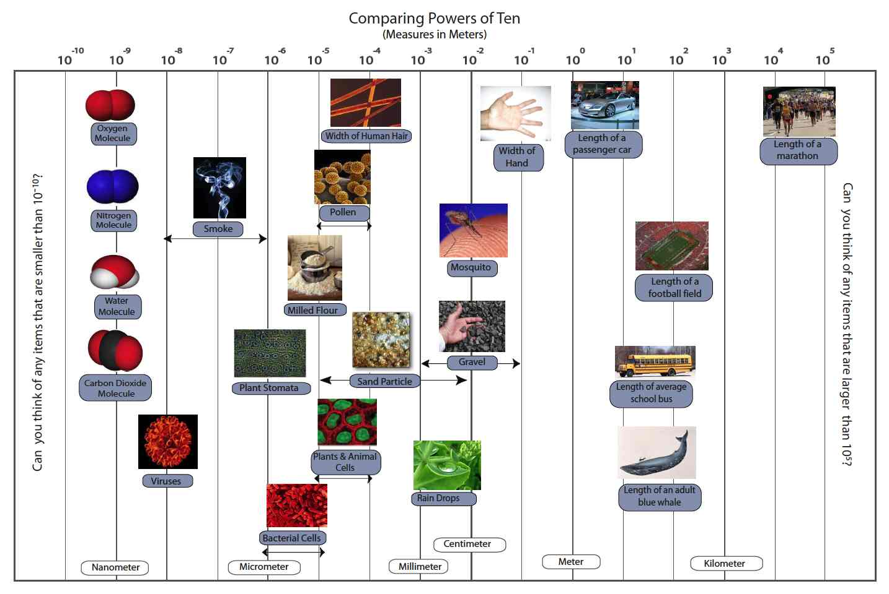
Powers of Ten Representation #1

Powers of Ten Representation #2

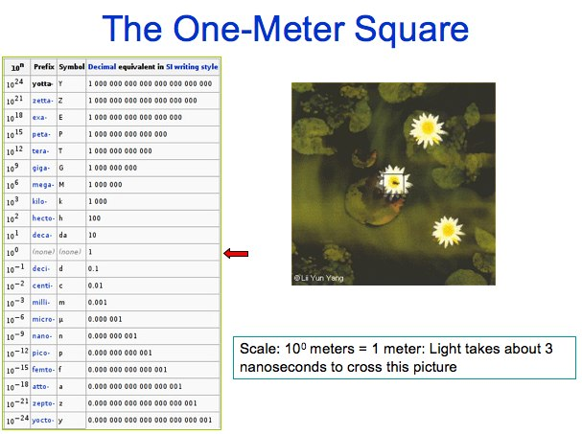

Matter and Energy

Molecular Model Kits

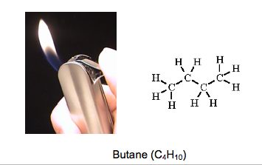
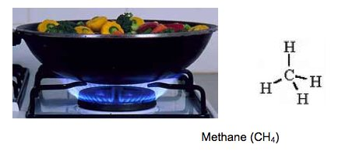
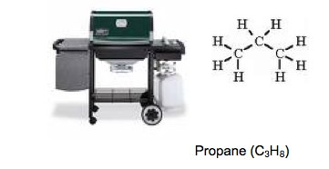
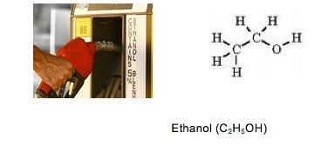
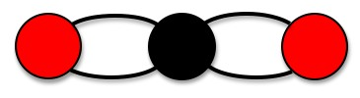
WATER MOLECULE

Matter and Energy Process Tool
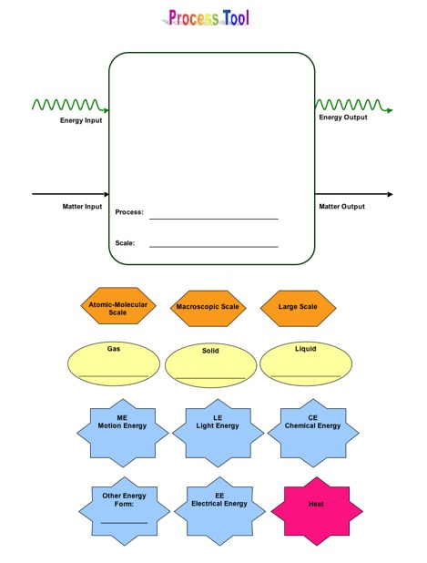

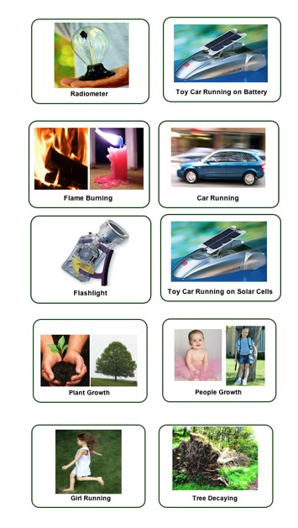

Combustion

Flame Representation #1
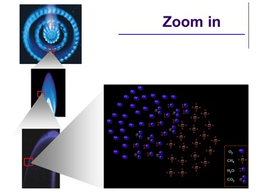

Flame Representation #2

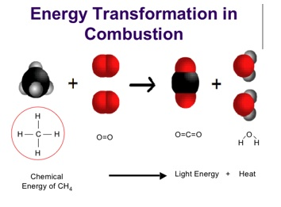
Material List

Class Materials
Powers of Ten DVD
Large-Scale Powers of 10 Color Vinyl chart
Large-Scale Process Tool with Laminated labels (and magnetic)
Set of Energy “Toys” or machines (solar car, motion flashlight, radiometer)

Overheads, Powerpoints, Simulations
1 Overhead projector/ vis a vis markers
1 Overhead Transparencies (1 each): (some black&white; some color)
Zooming In and Out- black and white transparency
Comparing Powers of 10: Blank- color transparency
Comparing Powers of 10: Partial answers- color transparency
Comparing Powers of 10: Answers- color transparency
Directions for Building Models
Powers of Ten powerpoints:
Powers of Ten powerpoint
Air powerpoint
Flame powerpoint
Process Tool powerpoints:
How can Machines work powerpoint
Explain Combustion powerpoint

Student Handouts
1 per student: Student pages (black and white copies)
Zooming In and Out
Applying Powers of 10
What is Air?
Building Air Molecules
How Can Machines Work?
Burning Materials
Does Burning Release Energy
Energy-Rich Materials

Student Handouts for Repeated Use (not written on and used again in each class)
30 per teacher (color)
Energy Forms (reading)
Identifying Energy-Rich Materials (reading)
Comparing Powers of 10 Answer Key (color copy)

Group materials
1 per group: Group materials
Comparing Powers of 10 Group Chart (blank)- black and white 3x4 ft.
Comparing Powers of 10 Cutouts (in color)- color copies
Molecule kits for each group: each group should receive at least 12 hydrogen, 18
oxygen, and 6 carbons and 36-40 springs. In addition, students will have 2 nitrogen.
Tape or sticky tack (to stick the cut-outs on the chart)- teacher supplies

Combustion Lab
Fuels: Methane, Butane, Propane, Ethanol
Lighter, Beakers, Tongs, ice or access to freezer

Activity 1: Powers of 10

General Overview:
Introduction: What does “system” and “scale” mean to you? ~ 10 minutes
Whole class: Powers of 10 video ~ 20 minutes
Individual/small groups: Zooming in and out: What can you see? ~ 10 minutes
(If Time): Whole group: Zooming In and Out with a 2nd look at video ~ 10 minutes

Estimated Time: 50 minutes

Purpose:
This lesson introduces students to the idea of using multiple scales to describe and connect systems. Students at the middle school level are likely aware of different scales, but possibly resort to describing systems and processes at the macroscopic scale because it is visible. This activity begins to teach students about 4 benchmark scales and the Powers of Ten. The lesson begins by eliciting students’ understanding of atomic-molecular, microscopic/cellular, macroscopic, and large-scale systems. The students then watch the Powers of 10 DVD (17 minutes), a video that shows the relative size of systems, from galaxies to subatomic particles. The video is approximately 17 minutes, but if time is an issue, the introductory material at the beginning of the video can be skipped (view video ahead of time to determine whether or not to use the full 17 minutes). The video should be used as a starting point for 1) revising students ideas about scale, 2) showing how systems can be viewed from multiple scales, and 3) providing students with a Powers of 10 framework for comparing different systems. After the video, the students have the opportunity to revise and modify their understanding of scale and systems. At this point, the main objective for middle school students is to start establishing 4 “benchmarks” for thinking about scale: atomic-molecular, microscopic/cellular, macroscopic, and large-scale. Students will build on these benchmarks in Activity 2 and then connect the benchmarks to Powers of Ten in Activity 3 when they use Powers of Ten as a tool for comparing systems.

Materials:
Powers of 10 DVD
Student copies of Zooming In and Out
Transparency of Zooming In and Out
Overhead projector & vis a vis markers

Advance Preparation:
- Watch Powers of 10 DVD (17 minutes) and determine how much of the video to use
- Get equipment to play DVD
- Run copies of Zooming In and Out (if not provided by MSU)
- Make transparency of Zooming In and Out (if not provided by MSU)

Procedures:
Introductory discussion: Systems and Scale ~10 minutes
- Before watching the video, it is important that students have some understanding of ‘system’ and ‘scale’. Spend the first 10 minutes developing a reasonable definition for these terms with your students. Some possible discussion questions might include:
  - In science we look at many different “systems”. What does this term mean to you? What do systems have in common that make them “systems”?
  - What does the word “scale” mean to you? (try to cue students to move beyond measuring scales, such as weight scales).
  - Possible definitions to use (you can use these before the video or wait until the discussion after the video, but at some point the class needs to have a common working definition for the terms ‘systems’ and ‘scale’ to use throughout the unit)
    - System: Set of connected and mutually interacting components
    - Scale: the range of measurement used for considering a particular system. You can use scale and measurement to compare the relative sizes of systems.

Powers of 10 video ~20 minutes
- Explain to students that they will watch a short film looking at how the same location can have many different systems at different scales. Students might want to take mental notes of what they see in the video, because images will change quicker than most will be able to write notes down. The DVD can be paused to allow students to further discuss particular images, but this can also wait until Step 4 below.

Zooming In & Out: What Can You See? ~10 minutes
- Pass out the Zooming In and Zooming Out student worksheet. Read the instruction with students and tell students that the list of things at the beginning of the worksheet are different systems or components of systems that were included in the video. Tell them that one way of thinking about scale is to group things in terms of 4 broad categories. These include atomic-molecular (things we cannot see or use a microscope to see; need a really powerful microscope to see), microscopic/cellular (we cannot see but can use a microscope to see), macroscopic (things we can see with our eyes), and large-scale (things that are too large to see with our eyes, but we can use representations and models to see, like a globe representing the Earth- the Earth being large-scale, the globe a macroscopic representation of Earth). Encourage the students to dissect the words, for example, discussing what “scopic”, “micro”, and “macro” means and develop a set of working definitions for each of these benchmarks scales. Tell students to look through the list on their handout and think about the video. Then have the students classify each system or component into 1 of the 4 broad benchmark categories.

Reflective Discussion: Systems and Scale ~20 minutes
- The reflective discussion can take a variety of forms depending on the available class time. NOTE: You will only need page 1 of the student handout unless you plan to watch the Powers of Ten video again. If time is short, focus the discussion on how students categorized the various systems on page 1 of Zooming In and Out and any discrepancies or disagreements they may have. Try to come to consensus about how to categorize the list of systems in terms of the benchmarks, and continue to review the benchmarks with students. If there is enough time remaining during the class period, consider watching the Powers of 10 video again, and review the zooming in and out table as a class, by pausing at each Power of 10. What appears and what disappears? Let students use Page 2 of handout if necessary. As you pause the DVD ask student which of the 4 broad categories does each systems belong to: atomic-molecule, microscopic, macroscopic or large scale. Again, focus the discussion on discrepancies and try to reconcile them by asking questions such as “Can we see it with our eyes? Can we see it with a microscope?”

NOTE: In Activity 2 you will continue to build on the 4 key benchmarks for scale (atomic-molecular, microscopic, macroscopic, and large scale) using Powers of Ten to locate things on the scale. Mostly this activity includes modeling of Powers of Ten by the teacher, and manipulation of a few key objects on a chart. During Activity 3 students will have a chance to manipulate and use Powers of 10.
Name: ________________________________________ Hour: __________

Zooming In and Out

When thinking about different scales we can generally group systems and parts of systems into one of four groups: 1) atomic-molecular (things we cannot see or use a microscope to see; need a really powerful microscope to see), 2) microscopic/cellular (we cannot see with our eyes, but can use a microscope to see), 3) macroscopic (things we can see with our eyes), and 4) large-scale (things that are too large to see with our eyes).

The following is a list of systems included in the Powers of Ten video. Try to sort these systems into one of the four categories described above.

Universe Man or Woman Cell Nucleus United States
Hand Earth Lake Michigan DNA molecule
Skin Carbon Atom Picnic Blanket Galaxy
Capillaries Skin Cell Quarks Chicago
City Park United States White Blood Cell Solar System

- What systems would you see at the atomic/molecular level?
DNA molecule, Carbon atom, quarks

- What systems would you see at the microscopic or cellular level?
Skin cells, cell nucleus, white blood cells, capillaries

- What systems would you see at the macroscopic level?
Body of a Person, skin, hand, picnic blanket, City park, Lake Michigan, Chicago

- What systems would you see at the large-scale level?
City park, Lake Michigan, Chicago, United States, Earth, Solar System, Galaxy, Universe

- Are there any systems that you are unsure about?

You will watch the Powers of Ten video again. However, this time your teacher will pause the video at each scale, and you will need to think about what appears and disappears when you zoom in or out. You will need to complete the table below, and as you watch the video again, think about the size of different systems and if they match the groups you made on the first page.

What You See When You Zoom In | Starting Point:  What You See | What You See When You Zoom Out
Picnic Blanket | City Park | Chicago
City Park | Chicago | Lake Michigan
Lake Michigan | United States | Earth
Earth | Solar System | Galaxy
Solar System | Galaxy | Universe
Skin | Hand | Body of a Man or Woman
Skin cells | Skin | Hand
White Blood Cell | Capillaries | Skin
Carbon Atom | DNA molecule | Cell Nucleus
Quarks | Carbon Atom | DNA

After watching the video again, is there anything you would change from your groups on the first page?

Zooming In and Out

What You See When You Zoom In | Starting Point:  What You See | What You See When You Zoom Out
 | City Park
 | Chicago
 | United States
 | Solar System
 | Galaxy
 | Hand
 | Skin
 | Capillaries
 | DNA
 | Carbon Atom

Activity 2: Powers of 10 As A Tool

General Overview:
Introduction to Powers of Ten Powerpoint ~ 20 minutes
Mapping Benchmark Scales onto Powers of Ten Chart ~ 10 minutes
Powers of Ten Chart and Practice placing Items ~ 20 minutes

Estimated Time: 50 minutes

Purpose:
The students have watched the Powers of 10 DVD, a video that shows the relative size of systems, from galaxies to subatomic particles. They have also learned definitions for the words “systems” and “scale” and learned about 4 benchmark scales: atomic-molecular, microscopic/cellular, macroscopic, and large-scale. In this second lesson, the Powers of 10 chart will be used as a framework for comparing systems at different scales, for example, comparing the size of molecules to cells and cells to leaves, etc. The teacher will first use a set of powerpoint slides to bridge what students saw in the Powers of Ten video to using powers of Ten as a comparative tool. The Powers of Ten powerpoint slides zoom in and out from Earth to molecules. Then students practice mapping benchmark scales to the Powers of Ten chart, and they will also begin mapping systems to charts. The goal of this lesson is to give students more practice with understanding scale and to help students see how Powers of Ten and the benchmark scales are both useful ways of comparing systems.

Materials:
Power of Ten (New).ppt (powerpoint)
Computer and projector OR overhead set and overhead projector
Comparing Powers of 10 Overhead Transparency: Blank (from master)
Comparing Powers of 10 Overhead Transparency: Partial answers (from master)
Blank Powers of Ten group posters
Small set of Powers of Ten cut-outs
Overhead projector & vis a vis marker

Advance Preparation: If not completed by MSU
- View Powers of Ten (New) powerpoint and practice projecting this powerpoint in classroom OR make overhead copies of each slide to use on overhead/opaque projector.
- Gather overheads for Comparing Powers of 10 (blank, partial)
- Gather poster-size copies of Comparing Powers of 10 Group Chart (blank) for each group
- Gather color copies of Comparing Powers of 10 Cutouts (students will only use a small set of these today, but will use all of them during Activity 3)

Procedures:
Introduce Powers of Ten using Powerpoint slides ~20 minutes
A powerpoint slideshow has been developed as a way of bridging the Powers of Ten DVD viewed during Activity 1 with the Powers of Ten charts that are used in Activities 2 and 3 and throughout other classroom activities. The Powerpoint allows the teacher and students to zoom in and out at various steps similar to the DVD. This format allows the teacher to go step by step through various systems and scales and talk about the size of the system (and start making comparisons to other systems).

There are 2 ways to use the powerpoint slides: Either on a computer projected to the class or by printing off overheads of the powerpoint slides and showing them on an overhead projector.

The powerpoint corresponds with many images of the Powers of Ten DVD but some images have also been replaced.

First have students review what they learned about systems and scale from Activity 1. Also ask students to share what they learned about the 4 benchmark scales.

Then use the powerpoint slides to teach about systems and scale. For each slide first ask students what the system is (i.e., a solar system, planet, flower, virus, etc). Ask students what benchmark scale the system belongs to (i.e., atomic-molecular, microscopic, macroscopic, or large-scale). As you get to the most familiar systems (Earth, cities, flowers, cells, virus, DNA), start modeling how to use the Powers of Ten to compare systems. These comparisons may be difficult for students, particularly those who struggle with math. As you model comparisons, pick examples from the familiar objects. For example, you might say, “A virus is 1 micrometer, but bacteria are 10 micrometers. That means bacteria are roughly 10 times larger than viruses”.

While the most important goal for middle school students is to have them learn and use the 4 key benchmark scales, the Powers of Ten can also be a useful tool for comparisons. At this age level consider focusing on the most familiar scale comparisons (i.e., systems at a meter are 100 times larger than systems at a centimeter, systems at a centimeter are 10 times larger than something at a millimeter, etc)

Introducing Powers of Ten Chart ~25 minutes
Introduce the “horizontal” powers of ten charts to students using the blank Powers of Ten overhead transparency. Explain that this new chart is a second way of representing the Powers of Ten chart and make comparisons to powerpoint slides. At this time consider mapping the powerpoint systems on the chart to bridge what students learned in the powerpoint slides to what they will be doing next with the powers of ten charts. Use a wet erase pen to write these items on your blank powers of ten overhead.

As you map items from the powerpoint to the chart, explain the axis on the chart and how to use Powers of 10. Although students may be familiar with powers of 10, they may not realize how to use it to compare the size of objects. One idea to emphasize here is that when you are comparing across such a wide range of scales, you don't need to know exact sizes of objects- that the powers of ten are helpful in making estimates about sizes and differences in scale.

Now that several items from the powerpoint are mapped onto the blank powers of ten overhead transparency, allow students to continue this mapping using a select group of “systems” found in the Powers of Ten cut-outs. Pass out the blank Powers of ten charts to groups of students. Ideal group sizes would be 3 (but no more than 4 students). Pass out a set of powers of ten cutout (listed below). Engage kids in using Powers of 10 by asking them to predict the location of those systems on the chart:
  - the length of an average school bus
  - the length of a passenger car
  - a rain drop
  - a sand particle
  - a particle of milled flour
  - particulate pollution (smog)
  - a plant stomate
Give students about 8-10 minutes to discuss these objects/systems and place them on the charts.

Then, as a whole class, mark student responses on the blank transparency using the vis a vis marker (similar to making the systems from the powers of ten powerpoint).

Then display the overhead transparency that shows the position of these items on the Powers of Ten Chart (this is the ‘partial’ overhead). Discuss differences in student responses, focusing on why they thought an object was larger or smaller than it actually is.

Whole class: Comparing Powers of Ten to 4 Broad Categories of scale ~5 minutes
At this point students need to map the 4 benchmarks onto the poster. Using the partial powers of ten overhead, have the students decide which powers of ten fall into each scale benchmark. The following are suggestions for how to divide the chart into benchmarks:

- Atomic-molecular (10⁻⁹)
- Microscopic (10⁻⁸ through 10⁻⁶)
- Macroscopic (10⁻⁵ through 10²)
- Large Scale (10³ through 10⁵)

Also point out the familiar measurements to students again: millimeter, centimeter, meter, and kilometer.

Collect the group charts and cut-outs to be used during Activity 3

Activity 3: Using Powers of Ten

General Overview:
Student groups: Completing Comparing Powers of 10 Group Chart ~ 20 minutes
Whole class: Checking the Comparing Powers of 10 Group Chart ~ 10 minutes
Student groups: Completing Applying Powers of 10 Worksheet ~ 10 minutes
Whole Class: Discussion of Applying Powers of 10 ~ 10 minutes

Estimated Time: 50 minutes

Purpose:
During the past 2 activities, students have learned about four broad scale categories or benchmark scales: atomic-molecular, microscopic, macroscopic, and large-scale. In Activity 2 students made comparisons between systems at each of the benchmark scales. Today they will spend time looking at a more detailed framework for comparing different scales using powers of 10. They will cut-out photos of the different objects and tape/stick them to the poster-size chart. The class will then talk about where certain things were placed. The teacher will give students a regular sized copy of the actual Powers of 10 chart for students to have and use. Then the students will work in partners or groups using Powers of 10 charts to make size comparisons between different objects in terms of powers of ten and in terms of benchmark scales.

Materials:
Comparing Powers of 10 Overhead Transparency: Blank (from master)
Comparing Powers of 10 Overhead Transparency: Partial answers (from master)
Comparing Powers of 10 Overhead Transparency: Answers (from master)
Student copies of Comparing Powers of 10 Answer Key
Student copies of Comparing Powers of 10 Group Chart (1 per group)
Student copies of Comparing Powers of 10 Cutouts (1 per group)
Student copies of Applying Powers of 10 Worksheet (1 per student)
Overhead projector & vis a vis marker

Advance Preparation:
- Gather overheads for Comparing Powers of 10 (blank, partial, answers)
- Gather color copies of Comparing Powers of 10 Answer Key
- Gather copies of Applying Powers of 10 Worksheet
- Gather poster-size copies of Comparing Powers of 10 Group Chart at Kinkos
- Gather color copies of Comparing Powers of 10 Cutouts

Procedures:

Group work: Comparing Powers of 10 Group Chart & Cut-outs ~20 minutes
In Activity 2 students placed a small set of systems (8 objects) onto their group charts. Today they will work to place these on the chart again and add to those systems. First pass out poster-size copies of Comparing Powers of 10 Group Chart (1 per group) and color copies of the Comparing Powers of 10 Cutouts (1 per group) and tape/putty.

Remind students that they have already worked with these charts and cut-outs before. As practice have students place the 8 systems from Activity 2 on the charts. The eight items include: the length of an average school bus, the length of a passenger car, a rain drop, a sand particle, a particle of milled flour, particulate pollution (smog), a plant stomate

Students have already learned the correct placement for these 8 objects during Activity 2 but may need help accurately putting them on the chart again.

Once all groups have placed these on their charts, have students respond to the following review questions:

- Are there any objects on our chart that are at the atomic-molecular level? (No) Can you think of any from the video or powerpoint?
- What systems/objects are at the microscopic level? (plant stomata, some particulate pollution)
- What systems are at the macroscopic level? (length of school bus, passenger car, rain drop, sand particle, milled flour)
- Are there any objects on the chart at the large-scale? (No) Can you think of any from the video or powerpoint?

Then give students about 5 minutes to guess at where the other cut-outs should be located on the chart.

Whole Class-Discussion of Poster-Size charts ~10 minutes
Have student groups share where they placed objects and note any disagreements between groups.

As a class, students should come to a consensus—with the teacher’s guidance—in regard to the positioning of the items on the Powers of 10 chart. At this time the teacher may show students an overhead copy of the actual placement of objects and pass out student copies of Comparing Powers of 10 Answer Key. The Answer key overhead and student handout contains the actual placement for all systems. Remind students that these are rough estimates. Then have student groups compare and contrast their poster-size charts with the ‘answer key’ and talk about objects that they misplaced or objects that were easier to place than others.

If time, have students add to the four questions above, in particular ask students, “have we added any systems that would be considered atomic-molecular or large-scale?”

Partner or Group Work: Applying Powers of 10 ~20 minutes

Pass out the Applying Powers of 10 Worksheet to individual students. Tell students that this will give them a chance to use powers of ten to compare the size of different systems. In order to do this, it will help to model the practice question with the entire class.

Because Powers of Ten may be difficult for many students, you may consider model other comparisons. You will need to show the students that each vertical line on the chart represents a x10 so as they move across each line they must times by 10.

Give students about 10-15 minutes to work on the different comparisons. If necessary allow them to work in partners or groups.

After most students complete Applying Powers of 10 worksheet, spend about 10 minutes discussing how students answered the comparative questions and if there were any difficulties or surprises as they worked.

If time, use the following question to probe what students have learned about scale:

How can we talk about water at different scales? Is there a way to describe water at an atomic-molecular scale (molecules)? How would be describe it at the microscopic scale (it is found in cells)? How would be describe it at the macroscopic scale? What are examples (rain drop, lake, cloud, etc)? Can you describe water at a large scale? (water cycle, oceans, etc) How much bigger is a small rain drop compared to a water molecule?

Name: _________________________________________ Hour: ____________

Applying Powers of 10

Now practice using the Powers of 10 to compare sizes of two different systems.

Practice Question:

How much larger is the width of a human hand compared to an average particle of sand?

The width of a hand is 10⁻¹ m and an average particle of sand is 10⁻⁴ m. So the width of hand is 10³ (or 1000) times larger than an average particle of sand.

- How much larger is an average particle of sand compared to an oxygen molecule (O₂)?
An average particle of sand is 10⁻⁴ m and oxygen molecule (O₂) is 10⁻⁹ m. So an average particle of sand is 10⁵ (or 100000) times larger than an oxygen molecule.

- How much smaller is the smallest virus from the largest bacteria?
The smallest virus is 10⁻⁸ m and the largest bacteria are almost 10⁻⁵ m. So the smallest virus is 10⁻³ (or 0.001) times smaller than the largest bacteria. Bacteria are about 100-1000 times larger than viruses.

- How much larger is the biggest piece of sand compared to the smallest piece of sand?
The biggest piece of sand is 10⁻² m and the smallest piece of sand is 10⁻⁵ m. So the biggest piece of sand is 10³ (or 1000) times larger than the smallest piece of sand.

- How much larger is a mosquito compared to a carbon dioxide molecule (CO₂)?
A mosquito is10⁻² m and a carbon dioxide molecule is 10⁻⁹ m. So a mosquito is 10⁷ (or 10000000) time larger than a carbon dioxide molecule.

- How much smaller is the smallest plant cell compared to a hand?
The smallest plant cell is 10⁻⁵ m and a hand is 10⁻¹ m. So a cell is 10⁻⁴ (or 0.0001) time of a small hand (or 10,000 times smaller than a hand). The hand is 10,000 times larger than a cell.

- Try to think of two more comparisons using the Powers of 10 chart

Comparison 1: e.g. How much larger is a piece of sand compared to a particle of tobacco smoke?
Comparison 2: e.g. How much smaller is an oxygen molecule compared to a cell?

Activity 4: What is Air?

General Overview:
Whole group: What is air? ~ 10 minutes
How Can We Look at Different Scales for Air ~ 15 minutes
Small Group: Building Air Molecules? ~ 25 minutes
Optional: Air Investigations

Estimated Time: 50 minutes

Purpose:
You can transition from Powers of Ten, by explaining to students that they now will learn more about the molecules at the 10⁻⁹. These molecules are found at the atomic-molecular scale, which means we cannot see them with our eyes and we cannot see them with a microscope.

This lesson is designed to get students thinking about air in terms of its molecular components. This is the first introduction of matter in this unit. This is also the first explicit attempt to introduce the idea that matter can be viewed from different scales. In many ways this activity serves as a bridge between what students have learned about scale and what they will continue to learn about matter at different scales. It is also a chance to explicitly teach about gases, which are particularly problematic for students.

Students will primarily discuss matter at the atomic-molecular scale by focusing on molecules found in air, but the lesson will begin with thinking about air at the benchmark scales and using a Powers or Ten powerpoint that show how air can be viewed at different scales. This powerpoint is similar to the powerpoint used during Activity 2, but it is now focused on air (or things found in air). At the macroscopic level, students should describe air as a substance that takes up space. But they may not understand that air is a mixture of gases. The component gases vary in proportion from place to place and time to time. At the molecular level, air is a mixture of different kinds of molecules, mostly N₂ and O₂ with small and sometimes variable amounts of other gases, such as CO₂, water vapor (H₂O), etc. Other substances may also be mixed in air, for instance, dust, germs, and smell of substances. Also at the molecular level, students should explain that breathing changes the air by increasing or decreasing the amount of CO₂, O₂, and H₂O. -- like all matter, air is made of molecules, so tiny that they are invisible, and constantly in motion.

Problems students may have: We speak of air as light, "airy," insubstantial”, or even as “nothing”. The topic of air causes difficulties for students because air is a complex mixture of gases that are generally colorless, odorless, and thus undetectable except by indirect means. Many important phenomena, including respiration, photosynthesis, humidity, smells, pollution, and the water cycle, are associated with variations in the mixture of molecules in air. Students must learn to see air and other gases as forms of matter like liquids and solids, with all the characteristics of matter in general: -- air is made of molecules -- air takes up space.

While this activity does not begin to cover the complexities associated with understanding gases as a form of matter, it does introduce students to the ideas that matter can be viewed at different scales using air as an important example.

Materials:
Powers or Ten Air powerpoint (either viewed on computer or as a transparency set)
Student copies of What is Air?
Student copies of Building Air Molecules
Molecule kits for each group
Overhead projector & vis a vis

If air investigations/demos are used, additional materials will be required.

Advance Preparation:
- Make copies of What is Air?
- Make copies of Building Air Molecules
- Have Powers of Ten Air powerpoint ready to go as a computer projection or as transparencies
- Make sure molecular modeling kits are sorted into ‘group kits’. Each ‘group kit’ should contain at least 12-hydrogen, 18-oxygen, 6-carbon, and 2 nitrogen. There should also be 36-24 springs for each group (mix of short and long springs). Students will not need all materials in today’s lesson.

Procedures:

What is air made of? (Intro & worksheet) ~ 10 minutes
Tell students that today they will continue to learn about different scales, but today they are going to use those ideas to explore what air is made of.

Pass out What is Air? As a whole group first review questions 1-4 on What is Air? Have students write down their initial ideas about air, but tell students they will get a chance to add to those ideas later in the activity. Give students time to think about ways of talking about air at different scales. At the macroscopic level, students may describe air as things that they can see and feel (e.g., breathe, blown-up balloon, the smell of perfume or a candle, the rise and fall of the chest, etc). They may also describe things like smoke, smog, fog, dust, etc. At the atomic-molecular level, students may describe air as the molecules previously discussed in Activities 1-3. Air consists of oxygen, nitrogen, carbon dioxide, water vapor, and smaller amounts of other gases. At the microscopic scale air contains particles, such as dust, pollen, etc. At large-scale students might describe air in terms of air quality, air pollution, wind, weather (such as air masses and currents/jet stream).

Powers or Ten Air Powerpoint ~15 minutes
Have students set their What is Air handouts aside for the moment. Explain that they are going to view a powerpoint about air using Powers of Ten. This powerpoint helps them look at how air can be viewed at different scale. Tell students to think about new things they can add to their What is Air handout.

View the Powers of Ten Air powerpoint with the class. This powerpoint includes slides that correspond to each benchmark scale. Go step-by-step through each slide and talk about what they see at each scale. Air at the large-scale can be talked about as the atmosphere and large air masses. At the macroscopic scale we see air as foggy or “hazy”, such as the air (smog, haze, fog) that surrounds a city. When zoomed in to microscopic scale, we can see air as solid dirt/dust particles or liquid drops of water suspended in gaseous air. This powerpoint gives the teacher the opportunity to point out that solid and liquid parts of air are visible, but that gaseous air still seems to be “nothing”. Then at the atomic-molecular (at the border between a water drop and gaseous air OR the border between a dust particle and gaseous air) students see that all of these types of matter are made of molecules and only look visibly different because of the space and movement between molecules.

In particular, focus the slides on helping students see that air is made of molecules and only seems like “nothing” because our eyes can’t see the molecules. BUT at a different scale gas, liquids, and solids all found in air are similar because they are made of molecules.

Ask students if the powerpoint gave them new ideas about what to add to their What is Air worksheet? Have students share what they would like to add to each scale category. Give students a couple of minutes to add to their handouts.

Building Air Molecules Model building ~ 25 minutes
Students will now have the opportunity to build air molecules. Before doing this, however, it will be important to review with students what they know about matter, especially whether gases are matter and if students believe they have mass. While this unit does not teach these concepts, it is important to be aware of what students believe in terms of gases. This activity can be used to show that while gases do not appear to have mass at the macroscopic scale, they do at the atomic-molecular scale.

After reviewing the powerpoint students should be aware that air is made of molecules. Explain that air is always air molecules, but that our evidence of these molecules can be described in terms of macroscopic and large-scale.

Tell students that matter is defined as something that has mass and takes up space. Ask students if air meets this definition at the macroscopic scale (and what is their evidence for or against whether air is matter)?

Tell students that they will be looking at air at the atomic-molecular scale and that they need to keep in mind whether air molecules meet the definition of matter. Explain that while these molecules cannot be seen because they are at the atomic-molecular scale, scientists use models to serve as examples of what molecules look like.

Pass out Building Air Molecules. Students will build models of the components of air: oxygen, carbon dioxide, water vapor, nitrogen. The teacher will need to spend about 5 minutes explaining the model kits and the different types of bonds that students will build. The students should feel comfortable with using the springs to connect ‘atoms’. Two important points in the explanation of the modeling kits:
  - Every hole in the ‘atoms’ needs to be ‘bonded’ to another atom or the model is not correct.
  - Shorter springs can be used for ‘single’ bonds and longer springs can be used for ‘double’ bonds

Students will need to work in groups of 2 (or 3) to build their models but there are enough materials that each student can build a molecule. Students should first try to build H₂O, CO₂, and O₂. Students can build additional molecules if time, for example nitrogen and methane. Tell the students to diagram the molecules on their worksheet and respond to questions.

Additional resources: If time, considering doing observations of air to show that air takes up space and has mass. Below are suggested demonstrations or investigations that may be useful for helping students see macroscopic evidence of air as a form of matter.

Air Investigations
There are several possible ways to conduct the following investigations. The teacher can gather students around the front of the room and demonstrate each one, while students record observations OR students can rotate through several stations, conducting the investigations and recording observations, then sharing with the whole group later. We recommend to conduct demonstrations in order to focus students attention and discussion on individual investigations. The decision also depends on available supplies.

Proceed with the investigations and make sure to focus discussions of the investigations on what it demonstrations- that air takes up space and has mass (which at the macroscopic scale is similar to solids and liquids).

Investigation #1: Move Air Under Water

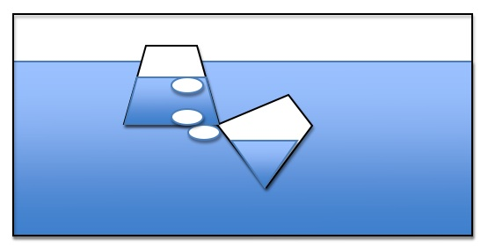
This investigation is a simple demonstration to transfer air between two submerged cups. Fill an aquarium or large, transparent container with water. Use 2 small plastic cups for the demonstration. As you submerged the cups, make sure one fills with water, while the other captures mostly air. Place the cup with the air tilted underneath the cup with water and slowly move the air back-air-forth between the cups. Ask students if the air or air bubbles take up space.

Investigation #2: Keep a Napkin Dry Under Water

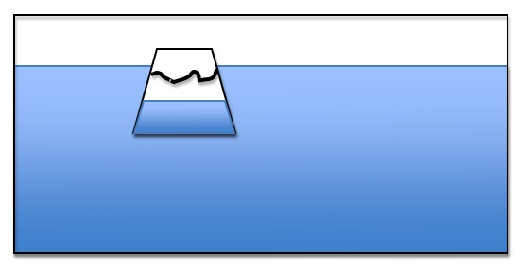
This investigation is a simple investigation to show that a napkin can stay dry under water. Take a tissue/napkin into the bottom of a clear cup. Fill an aquarium or large container with water. Flip the cup so that it is facing down. Carefully submerged the cup trapping air inside the cup as it enters the water. Be careful not to tilt the cup because this may release water. Slowly bring the cup out of the water. Let students fill the napkin to verify that it is still dry. Ask students if this shows that air takes up space.

Investigation #3: Blow-Up a Balloon

Tell students to blow up a balloon or blow up a balloon to demonstrate. Ask students what is inside the balloon. Ask students if the balloon shows that air takes up space.

Ask students to take a deep breath. What fills up their lungs? Does their chest expand? Is the air inside their lungs taking up space?

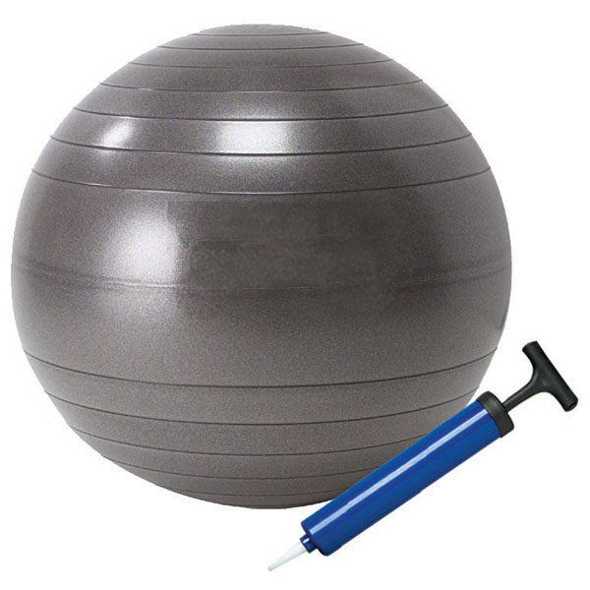
Investigation #4: Ball and Pump

The class may have a set of recess balls or you may need to borrow from the gym teacher or bring from home (MSU may supply if needed). Use a digital scale sensitive to 0.01g or 0.1g. You may need to borrow this scale from the middle or high school. Weigh an athletic ball on the scale and record the weight. Then use a ball pump to air up the ball. Make sure to get as much compressed air inside as possible. Then re-weigh the ball. Ask students, does this show that air has mass/weight? Make sure to weigh the ball carefully and to use the same ball for before and after since different amounts of plastic/rubber can change weight dramatically.

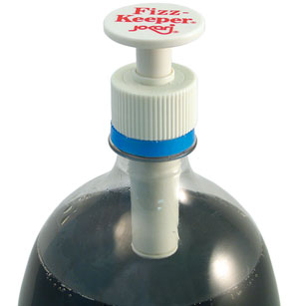

Investigation #5: Pump Air into a soda bottle

Use a two-liter soda bottle emptied and clean. Screw on the fizz pump. This pump allows you to pump air into the soda bottle. Tell students to watch as the soda bottle pumps up. You may also be able to weigh before and after if you have a sensitive scale, but the air will not be as dense as the gym ball demo so the difference may not be detectable. Students will observe the soda bottle becoming more rigid and when the pump is removed they will hear a “whoosh” of air.

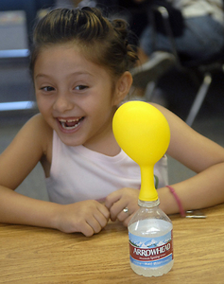
Investigation #6: Alka Seltzers and Balloon

This investigation uses alka seltzers and water, which when mixed, give off carbon dioxide gas. Use a soda or water bottle filled with an inch of water. Drop two alka seltzers into the water and quickly cover the top with a balloon. If the balloon is too small it may pop, so consider using larger balloons made of thicker material. The CO₂ gas will collect in the balloon. Ask students, what is filling the balloon? Does air take up space?

Investigation #7: Alka Seltzers and Scale

There are several ways to conduct this lab activity, but it is probably best done as a demonstration (for elementary students).

You will need an empty wide-mouth soda, water, or juice plastic container. Fill the container with an inch of water. Place the lid on top of the container. Then place 2 alka seltzer tablets on top of the lid. Weigh with a scale sensitive to at least 0.1g (0.01g is even better). Make sure all students see the weight.

Leave the bottle on the scale. Unscrew the lid and place the 2 alka-seltzer tablets inside the lid. Quickly turn the lid over (dropping the tablets in the water and screw lid back on bottle, allowing the tablets to drop in the water without letting too much air escape. As the tablets decrease, have students note the mass is still the same even though the bottle is expanding with air. Point out that the size of the tablet is decreasing, but air is increasing. The mass stays the same, so there is the same amount of “stuff” in the bottle, it’s just changing from solid to gas. Then unscrew the lid slowly to release the air. Watch the mass goes down as air escapes. Ask students, does the air (that came from the solid) have mass? Did it take up space?

Alternative: Suspension system

You will need an empty wide-mouth soda, water, or juice plastic container. Fill the container with an inch of water. Place two alka seltzer tablets in a mesh square cloth. Tie the cloth with thin string (such as fishing line). Dangling the mesh inside the plastic container just below the opening. Leave part of the string outside the container and screw on the plastic lid. Weigh the container on a scale sensitive to 0.01g (0.01g is even better).

Then turn the container upside down on the scale and allow the water to react with the alka seltzer. The bottle needs to be able to balance upside down so a wide mouth container may work best. Have students note that the mass is still the same. Point out that the size of the tablet is decreasing, but the air is increasing. The mass stays the same, so there is the same amount of “stuff” in the bottle, it’s just changing from solid to gas. Then flip the bottle over and unscrew the lid slowly to release the air. Watch the mass goes down as air escapes. Ask students, does the air (that came from the solid) have mass? Did it take up space?
Name: _______________________________________________ Hour: _________

What is Air?

We speak of air as light, "airy," or even as nothing. But what is air made of? Today you will learn more about the different molecules that make up air and have a chance to build these molecules using models.

Air is made of several gas molecules. The composition of air changes slightly from moment to moment and place to place, but approximately 78% is nitrogen (N₂), 21 % is oxygen (O₂), 1% is argon (Ar), and .03% is Carbon Dioxide (CO₂). There are other trace gases in air, such as hydrogen, helium, and neon. Water vapor is also a gas found in air. Water vapor ranges between 0-3% depending on the temperature and humidity.

There are other substances in air, including dirt, germs, bacteria, smoke, and many others. Most substances that you can see in the air, like dust or smoke, are made of solid particles that contain trillions of molecules each. These things are not air.

  - At the macroscopic level, how can you describe air? What things can we see and feel?
At macroscopic level, air is transparent. It has weight. It takes up space. It is a mixture of several gases including water vapor, carbon dioxide, nitrogen, oxygen, and so on.

  - At the atomic-molecular level, how can you describe air?
At the atomic-molecular level, air is a mixture of several gases. You can see different types of gas molecules mixed together. These molecules move randomly and collide with each other.

  - Can you think of large-scale ways to describe air and how it is used and influenced by living organisms?
Example 1 (Human impact)
At large-scale, human activities constantly influence the composition of air. With the development of technology and civilization, humans harness more and more energy from natural resources and meanwhile dispose more and more waste into environment. One major waste of human activities is carbon dioxide, which has been increased during the past one hundred years. The increased carbon dioxide in air causes the global warming effect, which in turn causes severe weather.
Example 2 (Natural Processes)
At large-scale, plants constantly inhale carbon dioxide from air and exhale oxygen in air to make food. They also constantly inhale oxygen and exhale carbon dioxide into air to use energy for function and growth. Animals constantly inhale oxygen and exhale carbon dioxide into air for their body function and activities. On the whole, without the impact of human burning fossil fuels, the composition of carbon dioxide and oxygen is constant in air.

4. Can you think of microscopic things that may be found in air?
Dust, pollen, smoke particles, etc
Name: ____________________________________________ Hour: ______________

Building Air Molecules

Your group will build the gas molecules that make up air and several important molecules for life. In order to do this, you will need to obtain a molecular model kits from your teacher. Before your group begins to build the molecules, you will need to know more about how to “bond” the molecules together.

Part I: Molecular Structure

Molecules are made of atoms bonded together. Today you will build several of the molecules in air and look at how the bonds hold the atoms together.

Single Bonds:
When two atoms share ONE pair of elections, it called a single bond. In water, for example, there are two single bonds.

Double and Triple Bonds:
When a pair of atoms share more than one set of electrons, these are called double and triple bonds. Oxygen and carbon dioxide molecules have double bonds.

Part II: Building Your Molecules

Familiarize yourself with the modeling kit. Open the bag/box and sort the pieces into similar piles. The round wooden pieces with holes in them represent various types of atoms. Each color represents a different element. To build your models you will need to use a color code to represent each type of atom:

Hydrogen- white
Oxygen- red
Carbon- black
Nitrogen- orange

The gray springs represent bonds. When you build molecules correctly, there should be no “empty” holes or bonding points.

Examine one of the hydrogen atoms. How many holes/bond points does it have? __1____

How many holes (bonding points) are in the carbon atoms? ___4____

How many holes (bonding points) are in the oxygen atoms? ___2____

How many holed (bonding points) are in the nitrogen atoms? ___3____

Build and diagram the following molecules:

Oxygen (O₂) Water Vapor (H₂O)

WATER MOLECULE

Carbon Dioxide (CO₂) Nitrogen (N₂)

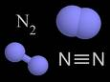

    - Look at your carbon dioxide molecule. Which atoms are bonded to each other in this molecule?

There are C-O bonds in carbon dioxide; carbon is bonded to oxygen

    - Look at your water molecule. Which atoms are bonded to each other in this molecule?

There are H-O bonds in water; hydrogen is bonded to oxygen

3. Are air molecules matter? Why or why not?

Air molecules are matter because they have mass (or weight) and they take up space. We cannot see this with our eyes, but we have know that air moves (wind) and has weight (like air pressure)

Activity 5: Energy and Machines

Overview:
Introduction ~5 minutes
Reading about Energy Forms ~10 minutes
Discuss Forms of Energy ~5 minutes
Transformations and Process tool ~30 minutes
Total time: 50 minutes

Purpose:
The word energy has both colloquial uses and scientific uses. The way ‘energy’ is used in daily life is very different from the scientific meaning of energy. The colloquial use of energy strongly influences students’ conceptions, thus causing many misconceptions and confusions about energy in science. This activity targets two crucial problems in students’ conception of energy by introducing a scientific framework that contains two parts – energy forms and a process tool.
The two major problems of energy conception and our instructional approaches are elaborated below:

1. Energy Forms

Based on their daily life, students have constructed a lot of ideas about energy. In their mind, energy is mostly associated with movement, activities, or life. Energy can also be a kind of semi-material which can appear and disappear mysteriously or can be converted from or into matter. All these ideas conflict with the scientific meaning of energy. In science, energy is an abstract quantity associated with certain evidences, such as light, sound, foods/fuels, etc. It cannot be converted from or into matter except in nuclear reactions. In this activity, we first introduce the notion of Energy Forms. A list of energy forms is introduced with explanation about how to identify each energy form based on its evidence. Energy forms are defined differently in different media or textbooks. For example, some textbooks address sound energy, which is also a type of motion energy. Solar energy is also light energy. Some different ways of defining energy forms are also addressed in this activity.

2. Process Tool

Based on their life experience, students tend to hold the idea that energy can be created or destroyed. For example, energy can be created by sleeping or rest. Energy is always used up and needs to be constantly replenished. These ideas conflict with the two fundamental energy principles in science: energy conservation (i.e., energy is always conserved) and energy degradation (i.e., heat is always released). In this activity, these two scientific principles are introduced by the Process Tool. The idea is that whenever there is energy input (represented by the incoming wavy arrow), there is always energy output (represented by the outgoing wavy arrow), so energy cannot be created or destroyed. Also, the energy output always contains heat, so not all energy can be used to do useful work or be passed on from one organism to another.

This activity intends to introduce the process tool by the simpler events of machines working. Students will observe how several scientific toys work and figure out how energy transforms in each event. These events are much easier than biological or chemical events since they do not involve matter transformation. Students are expected to understand energy transformation in this activity. The next activity (Activity 6) will add matter transformation to the process tool.

Materials:
Student copies of reading Energy Forms
Student copies of How Can Machines Work?
Overhead to write down key energy terms/principles
Large Process Tool and/or
Process tool powerpoint (How Machines work.ppt)
Energy “Toys”

Advance Prep:
- Make copies of student handouts if not provided by MSU
- Make sure process tool is ready to use
- Have a copy of How Can Machines Work.ppt and computer projector
- Gather Energy toys

Procedures:

Introduction 5 minutes
Ask students: what is energy? What types of energy do you know about? Take about five minutes for brainstorming.

Reading: Energy Forms 10 minutes
Pass out Energy Forms to students. The students will read through Energy Forms. As students read, stop the class and check student comprehension by asking the students to name other examples of that form of energy.

Discuss Forms of Energy 5-10 minutes
Take about 10 minutes to talk with students about each energy form as a summary of the reading. It is important to address the following 3 points:
- Energy is really hard to define, even for scientists. Forms of energy give us a way of talking about different types of energy, and how energy changes even if energy cannot be “seen”. Energy forms helps us identify energy.
- Energy is always conserved, even as it changes forms. We can always trace how energy is conserved by looking at how energy changes from one form to other forms.
- There is a difference between matter and energy: unlike matter, energy does not have mass and does not take up space; it is not made of molecules. Matter cannot become energy and energy cannot become matter.

Use Process Tool to Explain How Machines work 30 minutes
Introduce the two energy principles: energy conservation and energy degradation. Define these for students. Make sure that students understand how the two energy principles are related: the total amount of energy conserves, but the amount of useful energy always decreases due to heat dissipation (degradation). See “Notes to Teacher” below.

Tell students that they are going to do an activity where they show how energy is conserved by tracing how it changes in different types of machines.

Show students the process tool and tell them this tool is going to help them show how energy is conserved even when energy is changing forms. Use an example (e.g., lamp lighting up) to model how to use the process tool to explain energy transformation in processes. Use the large-size process tool, which is made of magnetic board and labels. Show that energy originally starts as Electrical Energy and changes to Light Energy and Heat.

Divide students into groups and explain that they are going to use the tool to show how energy changes in different machines. Use three toys to demonstrate four events: radiometer spinning under light, solar car running under sunlight, solar car running with battery, and motion flashlight lightening by squeezing the handle. On the student worksheet, How Can Machines Work?, there are questions about the four events. Students observe the demonstration and work together to figure out the energy input and output for each event. They then use this information to finish the blanks and questions on the worksheets. This will take about 15 minutes.

Allow time for the class to review each energy machine. Have student groups present their tables for the different energy machines and use the How Can Machines Work powerpoint to go through each machine/toy as a class. As students share their ideas, ask the other students in class if they agree with the energy forms and energy transformations that occur. Ask them how they know energy is conserved, and ask them if the event shows energy degradation. Students may use the large-size poster as they share their ideas with the class.

NOTES TO TEACHER

1. Challenges in teaching about energy
Scientific and informal uses of the word “energy.” Scientists sometimes use everyday words to label specific concepts they developed. Energy is one such word. We use the word energy in our everyday language, but energy, as a science word, has a specific meaning. Students hear their mothers remind them to drink enough water, because water will give them “energy.” Students may also feel that they get “energy” from vitamins, sleep, exercise, stimulants, etc.. None of these provide energy in the scientific sense.

Distinguishing energy from matter. We commonly suggest that some substances (e.g., glucose, ATP, gasoline) are energy, or that matter can be transformed into energy (e.g., “the wood burned up to produce heat and light”). THIS DOES NOT HAPPEN EXCEPT IN NUCLEAR REACTIONS. This is why it is important to keep matter and energy arrows separate in the process tool.

Defining and measuring energy. Unlike matter, energy cannot be seen even from the most advanced microscopes. You can hold a grind of sand in your hand, but cannot hold energy. You have learned how to identify energy by evidence. But, what is energy? What is the definition of energy? If you ask this question to scientists, they will give you many different answers. They will also tell you that memorizing the definition of energy is not important. So, what do scientists know about energy? Why is the concept of energy useful for us? Although we cannot see energy, there is always evidence of energy. In this lesson, we will learn how to identify the six most basic energy forms. Scientists can measure energy. They can measure the amount of energy you gained from a glass of milk. They can measure the amount of energy used to move a car from the city you live in to New York. They can also measure the amount of energy that operates a light bulb for one hour.

2. About the two energy principles. When scientists measure energy, they find two laws of energy transformation.

- Energy Conservation: The total amount of energy always stays the same.
Energy cannot be created or destroyed, it always transforms from one form to other forms. Energy always transforms. It cannot be converted into matter.

- Energy Degradation: The amount of useful energy always decreases, because heat is always released.
Whenever energy transforms, there is always heat released. Heat energy cannot be captured by plants and animals. So, although the total amount of energy conserves, the amount of useful energy always decreases.

The next series of activities focus on energy forms, especially chemical energy. It is important to understand that some materials can be used as energy sources, because they contain high-energy bonds. In the carbon cycle, there are two types of high-energy bonds: C-C bonds and C-H bonds. The materials that contain C-C and C-H bonds are organic materials, which can be used as energy sources for human living and activities. When these materials react with oxygen, energy is released. Materials with O-H or C-O bonds do not have the chemical energy necessary for life-sustaining processes or combustion. While you do not need students to talk about this in this lesson, you may have them note the types of bonds in the air molecules they built because they will need to compare air molecules to food and fuel molecules in the next lessons.
Energy Forms

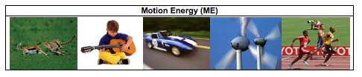Look around you. Many things are moving. They are in motion. Clouds drift across the sky. Leaves fall from the trees. A car speeds by. Birds fly. Whenever there is motion, we “see” motion energy. Holland is using wind energy, because it is clean and does not cause global warming. Wind energy is a kind of motion energy, because wind is moving air. Sound has energy. Sound energy is a special kind of motion energy. It is caused by vibration – the back and forth motion of air molecules.

Can you think of other examples of motion energy that you see every day?

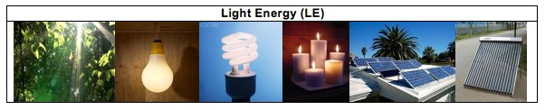
We use light every day. We use it to see things. Without light, our lives would be very difficult. Light helps our life more than just to help us see things. Sunlight helps plants grow. Doctors use special light to perform surgery. Light has light energy. When the lamp is turned on, it gives off light energy. When a candle is burning, the flame gives off light energy.

The light energy from sun is sometimes called solar energy. The sun is a giant ball of burning gas. It gives off light all the time. It will keep shining and giving us energy for millions of years. Plants capture and use light energy to make their own food. Scientists have also invented ways to use light energy. Solar collectors on house roofs can capture light energy and use it to heat the water in the house. Solar cells on cars and house roofs can also capture light energy and use it to make electricity.

Can you think of other examples of light energy that you see every day?

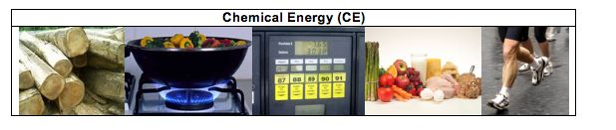Chemical energy is the energy stored in some special materials. Foods, fuels and body parts of all living things are made of materials that contain chemical energy.

All living things are made of cells. Cells are made of millions or even billions of molecules. The energy is stored in some molecules that make up cells. These molecules are carbohydrates and lipids (or fats). We call these molecules high-energy molecules. The molecules can be found in all living things.

Fossil fuels come from plants and animals living millions of years ago. The plant and animal debris was buried underground. Over long periods of time, the debris turned into fossil fuels. There are three types of fossil fuels – oil, natural gas, and coal. The major chemical component of fossil fuels is hydrocarbons. Like carbohydrates and lipids, hydrocarbons are also high-energy molecules. We use fossil fuels everyday. Our cars are powered by gasoline. We use methane for cooking. We use propane to barbecue and heat homes.

Can you think of more examples of things that have chemical energy?

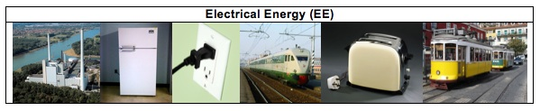
People use electricity everyday. Your family uses many electrical appliances at home. You watch TV after dinner. Your parents may use a laptop for work. You may use a toaster to toast bread or use a microwave oven to warm your food. To make these machines work, you should plug them into an outlet on the wall. What the machines get from the outlet is electricity. We not only use electricity to power our homes, school, or other buildings. We also use electricity for transportation. Electric trains or subway trains have engines that run on electricity. These engines get electricity through a metal rail under the train, or from wires at the top of the train. Electricity has electrical energy. Electricity is generated by different types of power plants. Wind power plants use wind to generate electricity. Nuclear power plants split uranium atoms to make electricity. Hydropower plants use the energy of moving water to make electricity. Fossil fuel fired power plants burn fossil fuels to generate electricity. In the United States, about 51% of our electricity comes from burning coal.

Do you know where your electricity comes from? What type of power plant do you depend on?
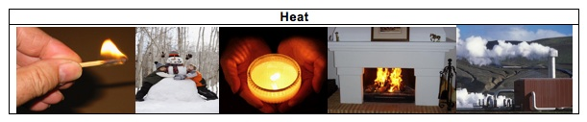
When you run a car for a while, the front of the car becomes very hot. When a flame from a candle or a campfire is burning, you can feel the warmth. When you are exercising, you also feel very hot. Even when you are playing outside on a cold winter day, your body stays warm. Your body temperature always stays close to 98.6°. In all these events, heat or heat energy is released. Geothermal energy is the heat within the earth. Geothermal power plants use the steam or hot water from the earth to generate electricity. Heat is a special form of energy. Whenever changes happen, heat is always released (lost) to the outside of the system as a byproduct. Unlike light energy and chemical energy, heat cannot be “caught” by any living organism to help their body function or to help them move.

Other Energy Forms

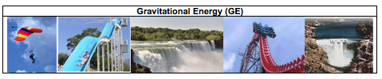Gravitational energy is the energy stored due to a higher position or place. A rock resting at the top of a hill contains gravitational energy. When the rock loses its support, it will roll down the hill. In this case, the gravitation energy transforms into the motion energy. Hydropower, such as water in a reservoir behind a dam, is an example of gravitational energy. Hydropower plants use the gravitational energy of the water to make electricity.
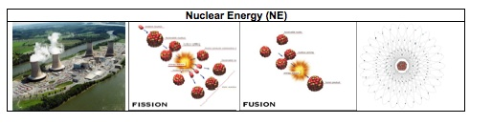
An atom is composed of electrons and a nucleus (neutrons and protons). Nuclear energy is the energy of the nucleus of an atom. There are two nuclear changes to release nuclear energy: fusion and fission. In fusion, nuclei are combined or “fused” together and nuclear energy is released in the form of heat and light energy. This is how the sun produces its heat and light energy. In fission, the nucleus of an atom splits apart and nuclear energy is also released in the form of heat and light energy. Nuclear power plants use the heat released from the fission of uranium atoms to generate electrical energy. Nuclear changes are different from chemical changes. Nuclear changes happen inside the atom, while the chemical changes only rearrange the atoms and do not change the atoms.
Name:_________________________________________ Hour:___________

How can machines work?

In this activity, you will use the Process Tool to analyze energy transformation in various events. The incoming wavy arrow represents the energy input to the machines. The outgoing wavy arrow represents the energy output from the machines. Please note that the process tool follows the two principles of energy:
- Energy conservation – Energy can transform from one energy form to other energy forms, but the total amount of energy conserves. (Energy cannot be converted into or from matter.)
- Energy degradation – Whenever energy transforms, heat is always released.

1. Radiometer: The radiometer is a light-bulb shaped device with a small weather vane in the middle of it. Place the radiometer under a lamp or sunlight and observe what happens when the light shines on it. Think about what happens inside the radiometer. Please use the process tool to analyze how energy transforms. Fill out the energy input and energy output in the table below.

 | Energy Input | Energy Output
Radiometer spinning | Light energy | Heat and motion energy

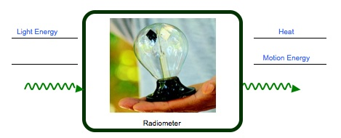
Note: process tool is NOT included on student worksheet. These are answer keys that correspond with the How can machines work powerpoint slides.
2. Solar Car #1: The solar car has a switch at the bottom. It can either run on battery or use solar cells. Put the switch on “solar”. Observe what happens when the car runs on solar cells. Please use the process tool to analyze how energy transforms. Fill out the energy input and energy output in the table below.

 | Energy Input | Energy Output
Toy car running on solar cells | Light energy | Heat and motion energy

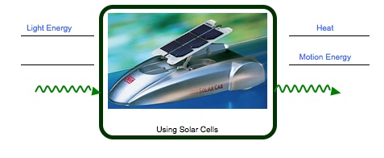
3. Solar car #2: Put the switch on “battery”. Observe what happens when the car uses the battery. What is the energy input? What is the energy output? Please use the process tool to analyze how energy transforms. Fill out the energy input and energy output in the table below.

 | Energy Input | Energy Output
Toy car running on batteries | Chemical-electrical energy | Heat and motion energy

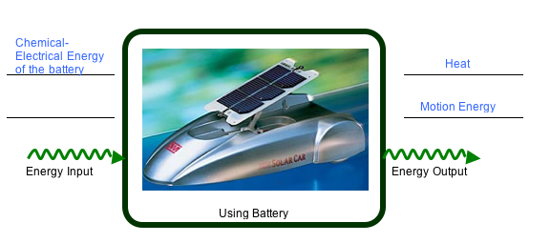

4. The Flashlight: In order to make the flashlight work, you will need to squeeze the handle back-and-forth. Observe what happens when you squeeze and release the handle. What is the energy input? What is the energy output? Please use the process tool to analyze how energy transforms. Fill out the energy input and energy output in the table below.

 | Energy Input | Energy Output
Toy car running on solar cells | Motion energy | Heat and light energy

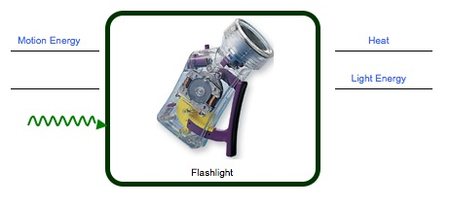

5. The four events are all about energy transformation. What patterns do you find in the processes of energy transformation?

There are two patterns:
1) Energy conservation: Energy cannot be created or destroyed. It only transforms from one form of energy to other forms of energy.
2) Energy degradation: Heat is always released.

Activity 6: What Happens When Fuels Burn?

Overview:
Review Forms of Energy and Chemical Energy ~5 minutes
Chemical Energy Lab ~20 minutes
Presentation of Group Work ~25 minutes

TOTAL TIME: 50 minutes

Purpose:
The purpose of this activity is to use combustion as an example to introduce the process tool with both matter transformation and energy transformation. Activity 5 introduces the process tool in a way that only discusses energy transformation. Activity 6 will add matter transformation to the process tool.

This activity focuses on two common misconceptions about matter and energy:

1. Matter-energy conversion – energy can be converted into or from matter. In science, energy transformation should be clearly distinguished from matter transformation. (Matter-energy conversion only happens in nuclear reactions.) So, in the process tool, energy is represented by the wavy arrows and matter is represented by the straight arrows. The rule is that wavy arrows cannot change into or from straight arrows.

2. In students’ conception, burning is treated as a process in which fuels or air are constantly consumed by flame. Some students may recognize that burning as chemical change, but gaseous reactants or products such as carbon dioxide, oxygen, and water vapor are usually not identified. In summary, most students do not hold the idea that chemical change is a process of atom re-arrangement. Although the molecules change in the reaction, the atoms remain the same. So, in the lab, students will observe what happens when different fuels are burning and identify the gaseous reactant and products involved in burning. Based on that, they will construct the idea that chemical reactions are a process of atom re-arrangement.

Materials:
Student copies of Burning Materials (with observation sheet & process tool diagrams)
Large-Size Process Tool
Powerpoint: Explain combustion.ppt

Combustion Demo:
Fuels: Methane (container of chafing gel, like those used in buffets), Butane, Propane (both butane and propane can be found as liquefied gases for uses in campstoves and the like – check labels; gas supplies into science labs generally use either methane, propane or butane), Ethanol (use either spirits or rubbing alcohol, although not isopropyl alcohol)
Lighter
Beaker
Tongs
Hot pads and hot plate (or other burn resistant surface)
Beaker(s) kept in freezer or on ice

Safety:
Goggles for teacher
Water, extinguisher nearby

Advance Prep:
Make copies of student handouts if not provided by MSU
Assemble materials for combustion lab demonstration
Make sure Large-size process tool is ready for use
Make sure computer/projector are ready to display Explain combustion powerpoint

Procedures:

Review Forms of Energy
Review the 5 key forms of energy from previous lessons. Review what students learned about chemical energy. Where is it found? (foods, fuels, all living things) What are examples of molecules that are not sources of chemical energy? (air molecules: water, carbon dioxide, oxygen) What happens when the energy-rich molecules react with oxygen? How does matter change? How does energy change? Tell students that today they will learn more about what happens when foods and fuels react with oxygen.

Lab: Combustion ~20 minutes
Pass out the Burning Materials worksheet. Students will observe what happens when different fuels are burning and record their observations in the table. Students are expected to identify the reactants and products involved in burning. In particular, gaseous matter including water vapor and oxygen should be identified.
In front of the class, burn the methane, butane, propane, and ethanol, one sample at a time. Before burning each material, introduce what the material is and how people use it in everyday life. Students also have that information in their worksheet. For the first burning sample:
- Ask students: what does the flame need in order to keep burning? Students may answer fuel, air, etc. Then invert the beaker over the flame. After a few minutes, the flame goes out. After students finish their observation, ask them to record their observation and answer the questions in the relevant column of the table.
- Ask students: what compounds are produced during burning? If they give general answers like ash or gases, challenge them to think of particular molecules they think will be produced. Then take a cold watchglass and hold it 15-20cm above the flame. Make sure that the glass is not put too close to the flame, or the water drops will not be observed due to the heat. After a few minutes, water drops should have condensed on the glass. After students finish their observation, ask them to record their observations and answer the questions in the relevant column of the table.
- Ask students: what kinds of energy are released by the combustion of this fuel? What kind of energy was present initially in the fuel?
For subsequent burning samples, you shouldn’t need to dwell on each question, but do encourage students to see the very regular patterns of transformation caused by combustion.

- Lead a class discussion on the patterns of the observations. Elicit the idea that all burning events require fuels and oxygen and produce water. Then tell students: There is another product in burning. Do you know what it is (the last column of the table)? Some students will come up with carbon dioxide, but they may not know why. Introduce the idea that chemical change can be treated as atom rearrangement – the atoms do not change, but they are rearranged to produce the new products. Ask students to use this idea of atom rearrangement to figure out the other product – carbon dioxide.

- Use several minutes to talk about the distinction between matter transformation and energy transformation: Matter transforms and conserves in chemical change. Energy also transforms and conserves in chemical changes. Energy cannot be converted into or from matter.

Presentation of Group Work 25 minutes
- Give students about 10 minutes to complete the tables for each fuel.

- Have different groups present their work. Use the Explain combustion powerpoint or the large process tool to model their answers.

Name: ___________________________________________ Hour: ________

Burning Materials

1. Please record your observations.

 | Reactants of Combustion |  | Products of Combustion
 | What is the substance that is burning? | Invert the beaker over the flame. What do you observe?  What substance is required to keep the flame burning? | Put a cold glass over the flame, what do you observe?  What substance is released? | There is another product of burning. Do you know what it is?
Burning methane | Methane | The flame extinguished a few minutes after the beaker was inverted over the flame.  Oxygen is required to keep the flame burning. | There are water drops on the glass. It means that water is released | Carbon dioxide.
Burning butane | Butane | The flame extinguished a few minutes after the beaker was inverted over the flame.  Oxygen is required to keep the flame burning. | There are water drops on the glass. It means that water is released | Carbon dioxide.
Burning propane | Propane | The flame extinguished a few minutes after the beaker was inverted over the flame.  Oxygen is required to keep the flame burning. | There are water drops on the glass. It means that water is released | Carbon dioxide.
Burning ethanol | Ethanol | The flame extinguished a few minutes after the beaker was inverted over the flame.  Oxygen is required to keep the flame burning. | There are water drops on the glass. It means that water is released | Carbon dioxide.

2. You have observed burning different types of fuels. You have also gained some information about different substances involved in burning. What are the patterns?
The pattern is that oxygen is required for the flame to keep burning. Water is released from the burning.

3. What are the forms of energy involved in these events of burning different materials? What are the evidences of different forms of energy?
Three forms of energy are involved: chemical energy of fuels; heat and light energy are released from the flame.
Part 2. Explain Combustion by the Process Tool

1. How does matter transform in burning? How does energy transform in burning? Please use the process tool to analyze and then explain how matter and energy transform in the table below.

 | Process | Scale | Energy Input | Energy Output | Matter Input | Matter Output
Burning Methane | Combustion | Atomic-molecular | CE of methane | Heat and light energy | Methane and O₂ | H₂O and CO₂
Burning Butane | Combustion | Atomic-molecular | CE of butane | Heat and light energy | Butane and O₂ | H₂O and CO₂
Burning Propane | Combustion | Atomic-molecular | CE of propane | Heat and light energy | Propane and O₂ | H₂O and CO₂
Burning Ethanol | Combustion | Atomic-molecular | CE of ethanol | Heat and light energy | Ethanol and O₂ | H₂O and CO₂

2. Inside a car engine, the gasoline burns in order to provide energy for the car to run.

What does the car need in order to run? Please use the process tool to analyze and then explain how matter and energy transform as gasoline burns inside the engine in the table below.

 | Process | Scale | Energy Input | Energy Output | Matter Input | Matter Output
Car Running | Combustion | Atomic-molecular | CE of gasoline | Heat and light energy | Gasoline & oxygen | H₂O and CO₂

3. When the car is running, where does the motion energy come from?

The motion energy comes from the chemical energy of gasoline

4. When the car runs out of gasoline and stops, where has the matter of the gasoline gone?

The gasoline becomes water and carbon dioxide.

5. When the car runs out of gasoline and stops, where has the ENERGY of the gasoline gone? Please note that when the car stops running, there is no motion energy.

All the energy transforms into heat.

6. Why do people use gasoline instead of water to run their cars?

Gasoline contains energy, but water does not contain energy.

7. Is it possible that all the energy of gasoline can be transformed into the energy of car running? Why?
No. Because the chemical energy of gasoline cannot be 100% transforms into motion energy. Heat is always released.

Process Tool Shown on the Board or Powerpoint- not student worksheet
Burning Methane

Process:

Scale:
(Matter Input)
(Matter Output)
(Energy Output)
(Energy Input)
Chemical Energy of Methane
Heat
Light Energy
Methane
Water (H₂O)
Oxygen (O₂)
Carbon Dioxide (CO₂)
Combustion
Atomic-molecular Scale

Burning Butane

Process:

Scale:
(Matter Input)
(Matter Output)
(Energy Output)
(Energy Input)
Chemical Energy of Butane
Heat
Light Energy
Butane
Water (H₂O)
Oxygen (O₂)
Carbon Dioxide (CO₂)
Combustion
Atomic-molecular Scale
Burning Propane

Process:

Scale:
(Matter Input)
(Matter Output)
(Energy Output)
(Energy Input)
Chemical Energy of Propane
Heat
Light Energy
Propane
Water (H₂O)
Oxygen (O₂)
Carbon Dioxide (CO₂)
Combustion
Atomic-molecular Scale

Burning Ethanol

Process:

Scale:
(Matter Input)
(Matter Output)
(Energy Output)
(Energy Input)
Chemical Energy of Ethanol
Heat
Light Energy
Ethanol
Water (H₂O)
Oxygen (O₂)
Carbon Dioxide (CO₂)
Combustion
Atomic-molecular Scale

Chemical Energy of Gasoline

Car Running

Process:

Scale:
(Matter Input)
(Matter Output)
(Energy Output)
(Energy Input)
Heat

Light Energy

Combustion
Gasoline
Water (H₂O)
Atomic-molecular Scale

Oxygen (O₂)
Carbon Dioxide (CO₂)

Activity 7: Does Burning Release Energy: Modeling Combustion

General Overview:
Review/Introduction ~ 5 minutes
Why can fuels burn? – Molecules of fuels ~15 minutes
How do matter and energy change in burning? ~15 minutes
Small groups: Modeling combustion ~ 15 minutes
Whole group: Concluding discussion ~ 10 minutes

Estimated Time: 60 minutes

*Optional complement: combustion as bond breaking and forming ~10 minutes

Purpose:
In Activity 6, students observed burning different types of fuels. In this activity, students will construct a more sophisticated molecular-level explanation for burning fuels. This activity has two purposes:

- To identify energy-rich materials.
Many students are able to identify fuels based on their daily experience. They know that fuels can burn because they contain energy, but they usually do not understand that the property of combustibility is determined by the atomic-molecular structure of fuels. Activity 7 will introduce the idea of using chemical bonds to identify energy-rich substances. By the end of this lesson, students will understand that energy-rich substances can provide energy for combustion because they contain high-energy bonds (C-C and C-H). Students are also expected to compare the available energy in molecules by looking at the number of C-C and C-H bonds.

- To explain matter transformation and energy transformation in combustion.
Students have learned about substances involved in combustion – fuels, oxygen, water, and carbon dioxide. They have also learned using the process tool to analyze matter transformation and energy transformation in burning. In Activity 7, they will continue to use this knowledge to investigate combustion process using Molecular Model Kits and Flame PowerPoint. The purpose is to help students to understand that chemical change is a process of atom re-arrangement and to distinguish matter transformation and energy transformation in the process. Many students have difficulty connecting the atomic-molecular chemical changes with the macroscopic phenomenon of flame burning. The Flame PowerPoint will help students to “zoom in” to see the components of the flame and understand that the flame is made of a mixture of molecules of the reactants and products in combustion. Then students will use molecular kits to practice relevant chemical equations. They will also compare the reactants and products in the process and identify energy-rich molecules and construct the explanation of energy transformation – chemical energy of fuel molecules transforms into heat and light energy in combustion.

Materials:
Powers of Ten Flame PowerPoint
Student copies of Does combustion release energy?
Molecular model kits (1 set per group)
Directions for Building Models overhead transparency

Advance Preparation/ Safety Considerations:
- Make student copies of Does combustion release energy? If not provided by MSU
- Assemble modeling kits that contain appropriate number of “atoms” and bonds”- each group should receive 12 hydrogen, 18 oxygen, and 6 carbons and 36-40 springs. In addition, students will have 2 nitrogen.

Procedures/Suggestions:

Introduction/Review ~ 5 minutes
- Introduction/Review. Take about five minutes to review what students learned yesterday as they observed the burning of different fuel sources. Ask them about the observations they made that indicate the presence of reactants and products. Ask them to explain what they learned by using the process tool to demonstrate how matter and energy change during combustion.

Why can fuels burn? – Molecules of Fuels ~ 15 minutes

- Students read the article about different types of fuels and finish the questions in part 1 – Why Can Fuels Burn? Use the Flame PowerPoint (Slide 1, 2, and 3) to show students the structure of fuel molecules and elicit the idea that fuel molecules have a similar structure: They all contain C-C and C-H bonds.

- Then introduce the concept of hydrocarbon: Hydrocarbon molecules all contain a carbon backbone. Hydrogen atoms are attached to that backbone. In this structure, the C-C and C-H bonds contain a lot of energy. Also make sure that students understand that each carbon atom has 4 electrons in its outer shell and thus can form 4 covalent bonds.

How do matter and energy change in burning ~ 15 minutes

- Ask students: what is flame? Show Flame PowerPoint (Slide 4 – Zoom In). Slide 4 uses methane as an example to show the composition of flame. Explain to students that flame is a mixture of gases including methane, oxygen, carbon dioxide, and water vapor.

- Remind students that in Activity 6, they learned that chemical reactions are a process of atom re-arrangement. Use the Flame PowerPoint (Slide 5 – Combustion as a Process of Atom Re-arrangement) to show the process of molecules breaking into atoms and atoms rearranging into new molecules. Then ask students to describe matter transformation in this process.

- Use the Flame PowerPoint (Slide 6 – Energy Transformation in Combustion) to lead students to consider whether energy is released or absorbed in combustion. Students examine the molecules of both reactants and products and identify energy-rich materials. In this case, the energy-rich material is methane, since it contains C-H bonds. Then ask students what is the evidence of energy they observe in burning? Elicit the idea that in combustion, the chemical energy of fuels transforms into light energy and heat.

Modeling combustion ~ 15 minutes

- Tell students that today they will use model kits to model what is happening to the atoms and molecules during combustion. They are going to model the four fuel sources that they burned in the previous lesson. Reminder that the point of the modeling is to show conservation of matter as well as energy.

- Divide students into groups and pass out molecular model kits. Remind students (from the air and fuel building activities, how to use the wooden atoms and springs to build molecules).

- Before starting the small groups tell students to think about the types of bonds that are in the reactants and the type of bonds in the products because that will help them decide what happens to energy during combustion. Either specify that C-C and C-H bonds are higher energy than O-C and O-H, or ask them to simply count the number of all types of bonds present in both reactants and products and let them come to the same conclusion.

- Students build molecular models according to the worksheet. They compare the molecular structures of the reactants and products to identify whether chemical energy is present in the reactants or products and how it transforms.

Concluding discussion ~ 10 minutes
- Take the last 10 minutes for class discussion and elicit the conclusions about the model-building activity and answers to the summary questions. When reactants contain chemical energy in high-energy bonds (C-C and C-H) and the products are not a source of chemical energy, the chemical reaction must release energy into environment- remind students that energy cannot be created or destroyed, so the chemical energy of energy-rich materials transforms into light energy and heat, which is what they observe at the macroscopic level. Help students connect this to what they observed in the burning lab demonstrations.

- Ask students how the atoms and molecules changed during the combustion process. Help students see that combustion does not create or destroy atoms or molecules, but just rearranges atoms into new molecules that are not sources of chemical energy. Help them see that burning is a chemical reaction in which a fuel source, often in liquid form, changes into gases.

If time, have students share their questions that are still unanswered, and see if other students have ideas about how to answer those questions.

*Complementary part (Flame PowerPoint Slide 7):

If you would like to teach for a higher level of knowledge about combustion, you can teach the complementary part. It introduce the idea of activation energy and use “bond breaking and bond forming” to explain why combustion is exothermic reaction. This is different from the method of comparing the energy of products and reactant to decide whether the reaction is exothermic or endothermic. If your students do not have sophisticated understanding of energy transformation and matter transformation, it is very possible that teaching bond breaking and forming will arouse more confusions and misconceptions.

The complementary part deals with the following common misconception hold by many high school students: energy is contained in bonds and energy is released when bonds break. It also explains why flame need to be initiated. Flame PowerPoint (slide 7) will help students to “see” the whole process of chemical change in terms of bond breaking and forming: A small amount of energy is required to break the bonds of fuel molecules and the bonds of oxygen. This makes the atoms (C, O, H) ‘free.’ Then these ‘free’ atoms bond together to form new molecules (CO₂ and H₂O). When the bonds form a large amount of energy is released. Since much more energy is released than absorbed, combustion releases energy.

Examples diagrams are below:

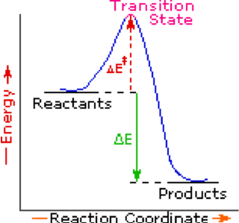
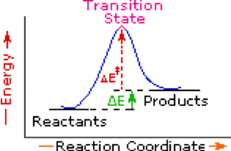
Endothermic
Single Step Reaction

Exothermic
Single Step Reaction

Name:______________________________________ Hour: ______________

Does Burning Release Energy: Modeling Combustion

Part 1. Why Can Fuels Burn? – Molecules of Fuels

In your groups, you will use molecular model kits to model the process of combustion of different fuel sources. You will model the following four fuels:

1. Burning Methane.
Methane, which takes up about 75% of natural gas, is used as energy source to heat your homes, cook food, or generate electricity.
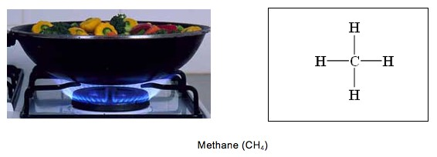

2. Burning butane.
In your classroom, you have butane burner for your chemistry labs. People often use butane lighter to light things, when they are having outdoor activities.
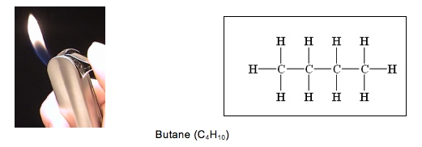

3. Burning propane.
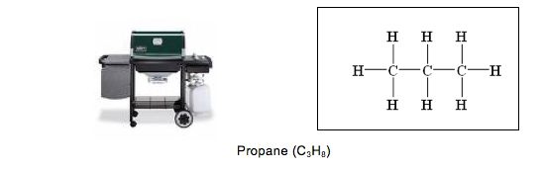
In the summertime, we often use gas grills to cook hamburgers and hot dogs. Many of the grills and camping stoves use propane fuel.

4. Burning ethanol.
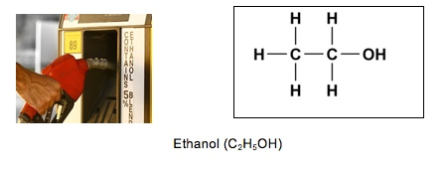
In recent years there has been increasing publicity and support for using ethanol from corn as a fuel source for our automobiles. Currently ethanol is mixed with gasoline and burned by engines in our vehicles.

6. Burning gasoline

Cars run on gasoline. Octane is the major component of gasoline. Usually, octane is combined with another hydrocarbon – heptane (C₇H₁₆) – in order to resist detonation or knock. An 87 gasoline has 87% octane and 13% heptane. Using a higher-level octane will not improve the gas mileage, since the total C-H and C-C bonds contained in the mixture will not change.

Octane (C₈H₁₈)

Questions

1. The article above provides information about molecules of different types of fuels. These molecules all belong to a class of substances – hydrocarbons. What is the similarity among the molecules? Please draw a picture to show the characteristic structure of hydrocarbons.

Answer:

2. Hydrocarbons are energy-rich materials, because they all contain certain chemical bonds. Please examine the molecules of different types of hydrocarbons. What are the chemical bonds that associated with high-energy?

All molecules contain C-C and C-H bonds.

3. Examine the different molecules. How many bonds can one carbon atom form?

Four bonds.
Part 2. Modeling Combustion

1. You have already burned some of these fuels and observed macroscopic changes in matter and energy. You will show what is really happening at the atomic-molecular level as these fuels burn. Matter transformation is described by the chemical equation of combustion as below.

Fuel + oxygen carbon dioxide + water

You will now use your model kits to demonstrate this equation for each fuel source. As you build your models, make sure to complete the tables.
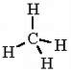
Chemical Change #1: Methane
Methane burns by combining with oxygen in the air to make carbon dioxide and water vapor. One methane molecule reacts with 2 oxygen molecules:

CH₄ + 2 O₂ → CO₂ + 2 H₂O

 | Reactants and Products of the Chemical Change |  |  | Does the substance contain Energy
 | How many carbon atoms does it have? | How many oxygen atoms does it have? | How many hydrogen atoms does it have? | What type of bonds does the substance contain? (C-C, C-H, O-H, C-O, O=O) | Is this substance energy-rich?  (yes or no)
Begin with…
Methane | 1 | 0 | 4 | C-H | yes
Oxygen | 0 | 4 | 0 | O=O | no
End with…
Carbon Dioxide | 1 | 2 | 0 | C-O | no
Water | 0 | 2 | 4 | O-H | no
Total amount of different atoms in reactants:
Carbon Atoms: ___1______ Oxygen Atoms: _____4______ Hydrogen Atoms: ____4_____
Total amount of different atoms in products:
Carbon Atoms: ___1______ Oxygen Atoms: _____4______ Hydrogen Atoms: ____4_____
Which molecule(s) contain(s) energy? _____CH₄____.
Chemical Change #2: Propane
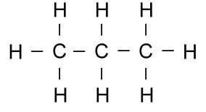
Propane burns by combining with oxygen in the air to make carbon dioxide and water vapor. One propane molecule reacts with 5 oxygen molecules:

C₃H₈ + 5 O₂ → 3 CO₂ + 4 H₂O

 | Reactants and Products of the Chemical Change |  |  | Does the substance contain Energy
 | How many carbon atoms does it have? | How many oxygen atoms does it have? | How many hydrogen atoms does it have? | What type of bonds does the substance contain? (C-C, C-H, O-H, C-O, O=O) | Is this substance energy-rich?  (yes or no)
Begin with…
Propane | 3 | 0 | 8 | C-C, C-H | yes
Oxygen | 0 | 10 | 0 | O=O | no
End with…
Carbon Dioxide | 3 | 6 | 0 | C-O | no
Water | 0 | 4 | 8 | O-H | no

Total amount of different atoms in reactants:
Carbon Atoms: ___3______ Oxygen Atoms: _____10_____ Hydrogen Atoms: ____8_____
Total amount of different atoms in products:
Carbon Atoms: ___3______ Oxygen Atoms: _____10_____ Hydrogen Atoms: ____8_____
Which molecule(s) contain(s) energy? _____C₃H₈____.
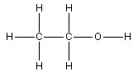
Chemical Change #3: Ethanol
Ethanol burns by combining with oxygen in the air to make carbon dioxide and water vapor. One ethanol molecule reacts with 3 oxygen molecules:

C₂H₅OH + 3 O₂ → 2 CO₂ + 3 H₂O

 | Reactants and Products of the Chemical Change |  |  | Does the substance contain Energy
 | How many carbon atoms does it have? | How many oxygen atoms does it have? | How many hydrogen atoms does it have? | What type of bonds does the substance contain? (C-C, C-H, O-H, C-O, O=O) | Is this substance energy-rich?  (yes or no)
Begin with…
Ethanol | 2 | 1 | 6 | C-C, C-H, C-O,  O-H | yes
Oxygen | 0 | 6 | 0 | O=O | no
End with…
Carbon Dioxide | 2 | 4 | 0 | C-O | no
Water | 0 | 3 | 6 | O-H | no

Total amount of different atoms in reactants:
Carbon Atoms: ___2______ Oxygen Atoms: _____7_____ Hydrogen Atoms: ____6_____
Total amount of different atoms in products:
Carbon Atoms: ___2______ Oxygen Atoms: _____7_____ Hydrogen Atoms: ____6_____

Which molecule(s) contain(s) energy? _____C₂H₅OH____.
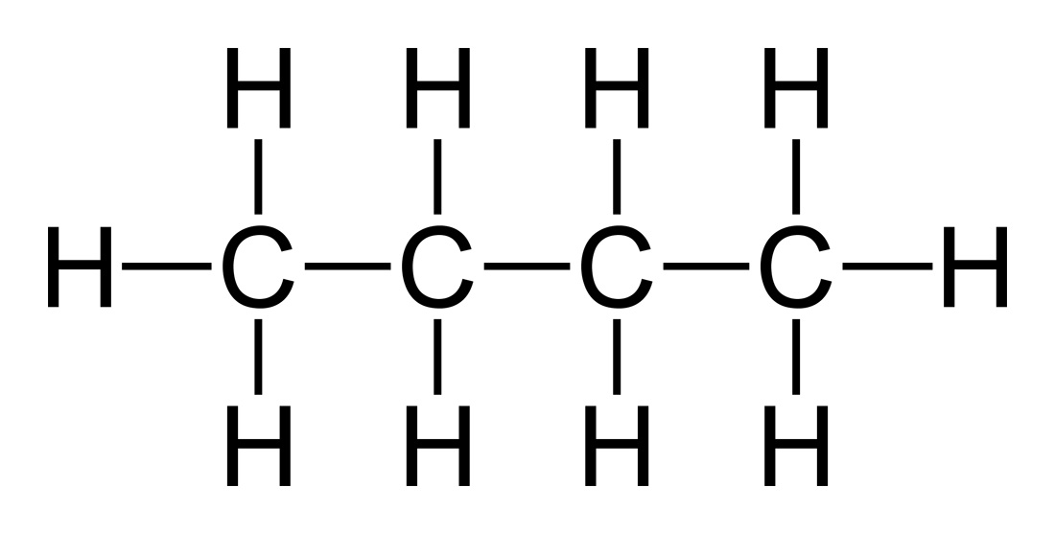
Chemical Change #4: Butane
Butane burns by combining with oxygen in the air to make carbon dioxide and water vapor. Two butane molecules react with 13 oxygen molecules:

2 C₄H₁₀ + 13 O₂ → 8 CO₂ + 10 H₂O

 | Reactants and Products of the Chemical Change |  |  | Does the substance contain Energy
 | How many carbon atoms does it have? | How many oxygen atoms does it have? | How many hydrogen atoms does it have? | What type of bonds does the substance contain? (C-C, C-H, O-H, C-O, O=O) | Is this substance energy-rich?  (yes or no)
Begin with…
Butane | 8 | 0 | 20 | C-C, C-H | yes
Oxygen | 0 | 26 | 0 | O=O | no
End with…
Carbon Dioxide | 8 | 16 | 0 | C-O | no
Water | 0 | 10 | 20 | O-H | no

Total amount of different atoms in reactants:
Carbon Atoms: ___8______ Oxygen Atoms: _____26_____ Hydrogen Atoms: ____20____
Total amount of different atoms in products:
Carbon Atoms: ___8______ Oxygen Atoms: _____26_____ Hydrogen Atoms: ____20____
Which molecule(s) contain(s) energy? _____C₄H₁₀____.
Summary Questions:

1. Each carbon dioxide molecule that is given off during combustion contains 1 carbon. Where was this carbon atom before it was in the carbon dioxide molecule?

It is in the molecules of different types of fuels.

2. Combustion is a process where energy-rich substances react with oxygen to make substances without high-energy bonds. What happens to energy in this process if it is no longer found as chemical energy?

It released out as heat and light energy.

3. Compare the reactants and products of combustion. Are there high-energy bonds (C-C and C-H) contained in reactants? Are there high-energy bonds contained in the products?

There are high-energy bonds (C-C and C-H) contained in the reactants, but not the products.

4. You have made models of energy-rich materials that we burn. How do the molecules change when they are burned? What happens to the atoms?

The molecules change after the chemical reaction: the molecules of fuels react with oxygen and produce carbon dioxide and water.

The different types of atoms keep the same.

5. Please use two equations to show how matter transforms and how energy transforms during combustion. Then answer the following questions:

Fuel + oxygen carbon dioxide + water
Chemical energy of fuels Light energy + Heat

a) Compare the amount of different types of atoms before and after the chemical change. What pattern do you find?
The amount of different types of atoms kept the same.

b) Does the total amount of energy change after the chemical reaction?

The total amount of energy conserves. It transforms from chemical energy of fuels into light energy and heat.

QUESTION YOU STILL HAVE:

Do you still have questions about how matter or energy change during combustion? In the space below, write about new things you learned about combustion, or questions you have that were not answered during the previous activities.
Directions for Building Models:

Step 1: First build the “fuel” molecule.

Step 2: Use the remaining oxygen molecules to build O₂

Step 3: Once you have the reactants built, think about the atoms in each molecule and the bonds between atoms and complete part of the table.

Step 4: Use the reactants to “simulate” combustion of the fuel source. Recombine the atoms from the fuel molecule and oxygen molecules to make carbon dioxide and water.

Step 5: Look at the atoms in the products (carbon dioxide and water) and the bonds between atoms. Complete the rest of the table.

Step 6: Do steps 1-5 for each of the fuel molecules.

Step 7: Once you have completed all the fuel sources and tables, discuss and respond to the questions on the last page.

Activity 8: Identifying Energy-Rich Materials

Overview:
Reading Identifying Energy-Rich Materials ~15 minutes
Energy Rich Materials ~25 minutes

TOTAL TIME: 40 minutes

Purpose:
This activity allows students to continue practicing using high- and low-energy chemical bonds, but with a more explicit focus on the energy-storage molecules used by living cells. In this way it can serve as a bridge between the physical and chemical discussions that have been the gist of earlier lessons, and the working out of these principles in biological systems, setting the stage for examinations of metabolism and other processes in living organisms in upcoming modules.

Materials:
Student copies of the reading: Identifying Energy-Rich Materials
Student copies of Energy-Rich Materials

Advance Preparation:
Make copies of student worksheets if not provided by MSU

Procedures:

Identifying Energy-Rich Materials 15 minutes
As a group read through the handout titled, Identifying energy-rich materials. Focus subsequent discussion on insuring the students are clear on the source of stored energy in cells, namely solar energy captured in photosynthesis by plants and transferred to animals when they consume the energy compounds of plants or other animals. When cells break apart these high energy molecules we call it cell respiration rather than combustion, but the processes use similar reactants and have the same products. A related point is to show the similar nature of fossil fuels to biological energy stores, except that their matter and energy were part of the biosphere millions of years ago. Modern humanity’s rapid combustion of the energy molecules stored over a long time period is at the heart of the changing global carbon cycle.

Energy-Rich Materials 25 minutes
Elicit students’ ideas about why some materials can be used as energy sources for human survival and activities, while some materials cannot. Try to guide students to developing an explanation that uses the chemical bonds of the materials (i.e., all the energy-rich materials contain C-C and C-H bonds). If time allows, beginning to discuss the relative sizes of the energy molecules (glucose vs. lipid, for instance) will allow students to think about the density of high-energy bonds in a molecule, and their overall energy storage capacity. This plays out for students in such things as why the body stores energy primarily in fat, and why fat contains more calories than sugar on a weight basis. This is also a good place for students to share claims that occasionally surface about harnessing energy from low-energy compounds, such as hydrogen fuel cells that are sometimes talked about as producing fuel energy from water, ignoring the earlier sources of energy that have to be inputted to set up the fuel cell.

Identifying energy-rich materials

Part 1. Chemical Energy in Plants, Animals, and Fuels

Where do plants and animals store energy in their bodies? Plants and animals are made of cells. The cells are made of millions and even billions of molecules, all used for a wide variety of purposes. The majority of a cell’s energy, however, is stored in several special types of molecules.

The picture below shows that leaves of corn plants are made of cells. These cells are able to capture light energy from the sun, and transform it into chemical energy through the process of photosynthesis. In this process, atoms found in carbon dioxide and water are used to make glucose molecules, which contain a lot of chemical energy. Eventually the glucose molecules become other types of molecules in plants, such as starch and cellulose. Cellulose molecules also contain a lot of chemical energy. Like glucose, cellulose is important to plants. Cellulose, however, is much less biologically accessible than glucose and starch for organisms to use as food, making it an excellent molecule for durability and structure, such as in plant cell wells, where it is the major chemical component (see picture below).

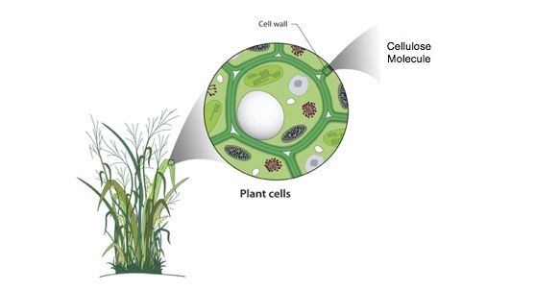
Plants also take in oxygen, because they need to be able to use the chemical energy in glucose and other molecules. Oxygen helps to release the chemical energy stored in these molecules. When the molecules react with oxygen, their chemical energy is used by the plant, and transformed into other forms of energy. At the same time, carbon dioxide and water are released out of the cell, and may eventually leave the plant.

People and other animals store energy in their bodies in a similar way, using molecules such as glucose, glycogen (very similar structure to plant starch) and lipids (fats). The muscle of the person’s arm is made of muscle cells. The muscle cells store millions of lipid molecules in specialized parts of the cell. Like cellulose molecules in plant cell walls, the lipid molecules also contain a lot of chemical energy. Unlike cellulose, though, lipids can be readily broken down by the cell and their stored energy released.

Just like plants, people need oxygen to release the chemical energy stored in the cells of their body. In the picture below, when the lipid molecule reacts with oxygen, its chemical energy is released for the person to use. At the same time, carbon dioxide and water are released out of the cell, and eventually leave the body.

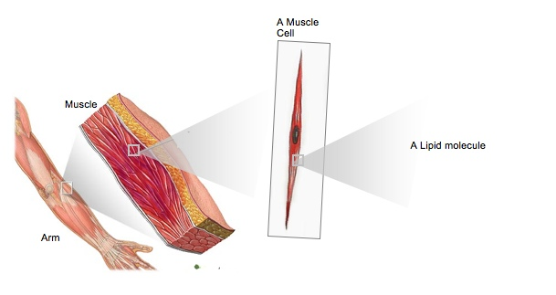

Where Do Fossil Fuels Come From?

Picture 1 2 3
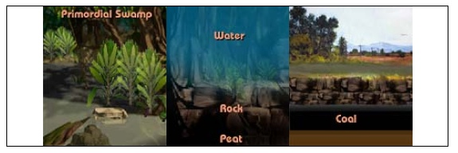

Fossil fuels were formed from plants and animals that lived approximately 300 million years ago in primordial swamps and oceans (Picture 1). Ancient plants and animals died and were buried under layers of sediment and eventually rock (Picture 2). The high temperature and pressure cause the debris (peat) to condense. Gradually the condensed organic matter was transformed into fossil fuels, like coal and oil, buried underneath layers of rock (Picture 3). These fuels retain much of the chemical energy present in the organisms when they were living.

The most commonly used fossil fuels are oil, coal, and natural gas. These substances are extracted from the earth’s crust and refined into suitable fuel products. Crude oil is refined into gasoline, diesel fuel, and jet fuel, which power the world’s transportation systems. Coal is the fuel most commonly burned to generate electric power for homes and buildings. Natural gas is used primarily in buildings for heating water and air, for air conditioning, and as fuel for stoves and other heating appliances.

In order to release the chemical energy found in fossil fuels, we must “burn” those fuels using oxygen. This process is called combustion. Combustion happens when oxygen reacts with fuels to release chemical energy. Note that this is essentially the same as the reactions discussed above in plant and animal cells; combustion is simply more tightly controlled in living cells, and called cell respiration. The chemical energy may change into many other forms of energy. In a coal power plant, the chemical energy changes to electrical energy and heat. In a car engine, the chemical energy in gasoline changes to motion energy and heat. When other types of fuel, like propane, are burned on a gas grill the energy changes from chemical energy to light and heat. When all these fuels burn, the matter that makes up the fuel changes to carbon dioxide and water. Since they are fossil fuels, however, the matter and energy being released during combustion is ancient, and was last present in the earth’s atmosphere millions of years ago. Wide-scale use of fossil fuels in recent centuries has dramatically increased the concentration of gases like carbon dioxide in the atmosphere, and is the principal cause of the greenhouse effect and global warming.

Part 2: C-C and C-H Bonds and Chemical Energy

Look at some of the common molecules that make up plants, animals, and fossil fuels.

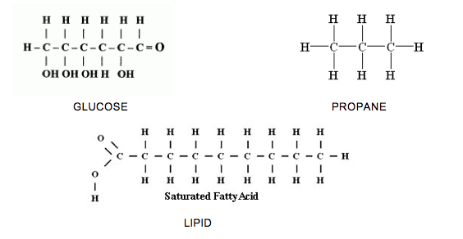

What do you notice about the atoms that are found in these materials?

What atoms are bonded to each other?

In general molecules that have C-C and C-H bonds have lots of energy. That means when you see a molecule where carbon is bonded to another carbon, or where carbon is bonded to hydrogen, that molecule has lots of chemical energy. Some molecules are not rich with chemical energy. These molecules contain O-H and O-C bonds. Materials that only include oxygen bonded to hydrogen or oxygen bonded to carbon are not chemical energy sources.
Name:________________________________________ Hour: ___________

Energy-Rich Materials

N≡N O=O O=C=O O-H-O
Nitrogen Oxygen Carbon Dioxide Water

1. Look at the molecules that make up most of our air. Do you think these molecules are sources of chemical energy? Explain why or why not.

No. Because these molecules do not contain C-C and C-H bonds.

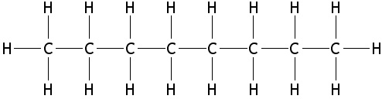

2. a. This is an octane molecule found in gasoline. Is this molecule similar or different from the fuel molecules you built in the previous lesson? Explain why it is similar or different.

Yes. They are similar, because they all contain C-C and C-H bonds.

b. Which of the molecules in the reading (glucose, propane, lipid) is most similar to the octane molecule? What might this mean in terms of energy storage for plant and animal cells?

Propane, because propane molecule and octane molecule only contain C and H atoms, but glucose and lipid molecules also contain O atom.
Look back at the all the molecules you built using your model kits and other molecules you read about today. Which molecules have chemical energy and which do not? Complete the table below.

Which molecules have chemical energy? | Which are NOT sources of chemical energy?
butane, propane, ethanol, octane, methane, | nitrogen, oxygen, carbon dioxide, water

Summary Questions:

1. What makes the molecules with chemical energy similar?

They all contain C-C and C-H bonds.

2. How are molecules with chemical energy different from the molecules without chemical energy?

Molecules with chemical energy contain C-C and C-H bonds, but molecules without chemical energy do not contain these bonds.

